THE JEFFERSONIAN GAZETTE
THOMAS JEFFERSON CHAPTER
SPRING ISSUE – 2020
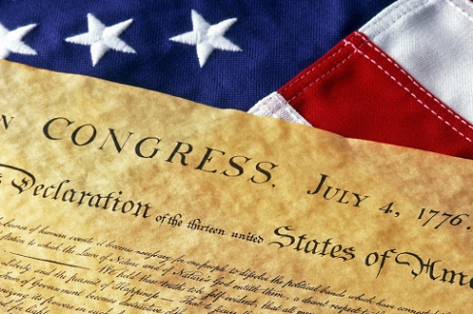
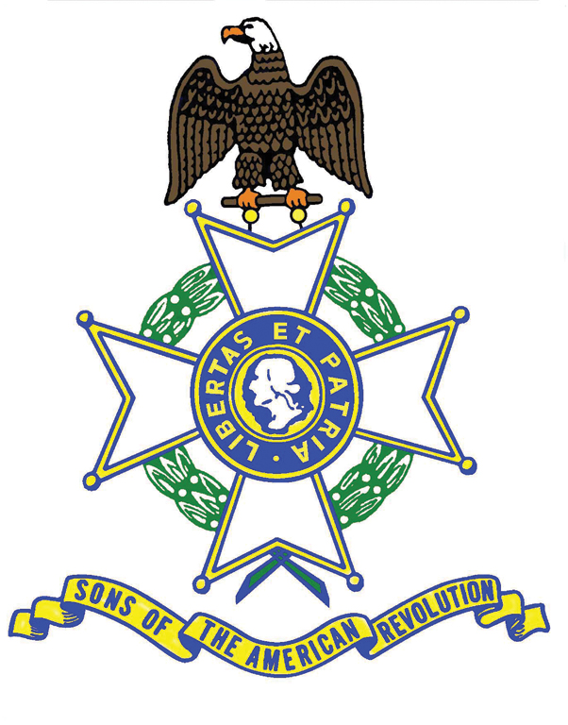
President’s Message -Compatriots: Well I did not in my wildest dreams think my third year as your President would have been effectively paralyzed by the Covid-19 Chinese Virus and the ensuing economic catastrophe, followed by the Black Lives Matter and Antifa protests and riots. It is hard to imagine what might be next. In spite of all these distractions, our activities have continued, but at a much slower pace as you will see when you read the details inside. We started in January with several presentations to adjacent chapters presenting the 2020 NSSAR National Congress and asking for volunteers to help us in Richmond in July. We had over 100 volunteers across the state and were well into the final plans when NSSAR had to cancel the event because Richmond could not assure our safety by 7 July, etc. That was very disappointing for many of us who put in incalculable numbers of hours over the last two years. Jan and I made a ten-day Pilgrimage to the Holy Land and arrived back in time for the VASSAR Annual meeting and then The Crossing of the Dan Ceremony in South Boston. We had a great Men’s Breakfast on 7 March at Farmington after which the rug was pulled out from under us. Suddenly EVERYTHING was cancelled or postponed until the Fall! It wasn’t until VASSAR sponsored a National Event “virtually” on ZOOM for Patriot’s Day that we got moving again. Since that time, we have participated in three Virtual Events and one live event recently in Culpeper. Now that we are all beginning to slowly resume some sense of normalcy, Jan and I are looking forward to hosting our TJC Annual Garden Party with special guest, VASSAR’s 100th President Bill Schwetke, and his wife Cat who will join us at our home again this August 23rd at 5 pm for a Mission BBQ catered meal and fellowship on our lawn and in our garden areas. We hope that you will make a special effort to attend. You may wear masks and maintain social distancing as you prefer. We believe it is important to get together in fellowship again! Please encourage your children and grandchildren to participate in SAR events with you. They are our legacy and the organization’s future. Thank you for allowing me to continue to serve as your President. Jan and I consider it a great honor and a wonderful privilege. Stay healthy. Semper Fi. James O’Kelley
-2- PAST EVENTS
Feb. 7,8 Virginia Society Annual General Meeting
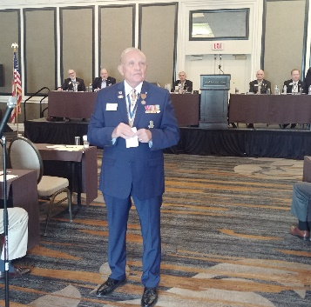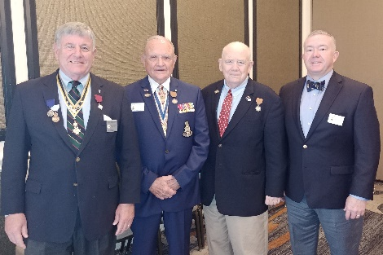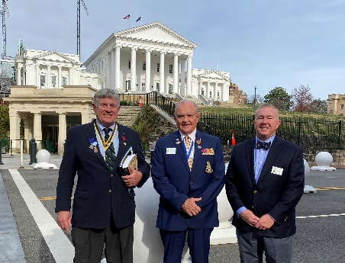
Above left, President O’Kelley gives the Chapter Report at the Saturday morning AGM. Naturally, he took liberty to share a bit of “Irish” humor with the Compatriots. The Chapter wishes to thank Compatriots Williams, O’Kelley, Kelly and Cooke for attending the AGM. Following the meeting, the Rambaugh Oration contestants, from memory, delivered terrific orations on subjects tied to the Revolutionary War Era. After lunch, the Compatriots gathered in the Senate Chamber of the State Capitol for the Awards Ceremony. Seen below left, fourth from the left, Chapter President O’Kelley, proudly holds a Chapter Excellence Award for the Thomas Jefferson Chapter. Below right, for the second time (2014), Compatriot Williams won the Chapter News Letter competition.
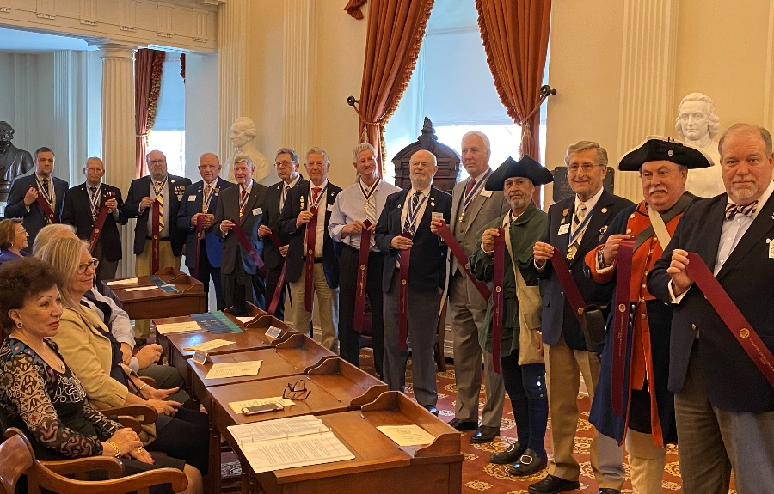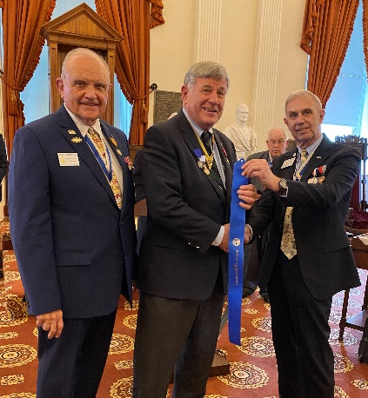
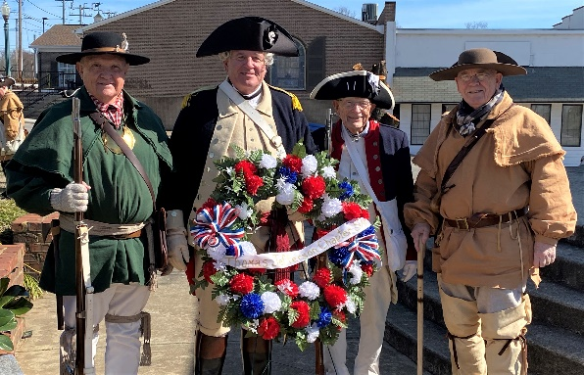
Feb. 15 The Commemoration of the Crossing of the Dan The Chapter thanks Compatriots O’Kelley, Williams (the Crossing MC), Wallenborn, and Kelly for attending this Nationally-recognized event. The Crossing had a great turn-out, with Compatriots coming from Tennessee, Texas, North Carolina and Kentucky. The water had overflowed the banks of the Dan, so re-enacting the Crossing was unsafe. In fact, the monument was underwater.

-3-
“MC” Williams on left co-hosting” Berryman Greene DAR Chapter’s Anne Raab, bringing greetings for VDAR. We were all treated to a wonderful presentation of period music.
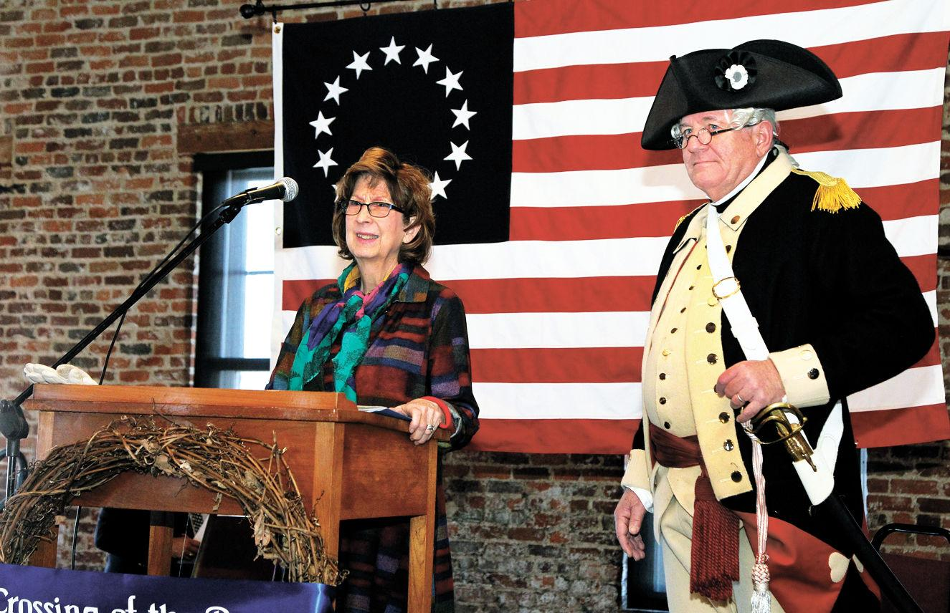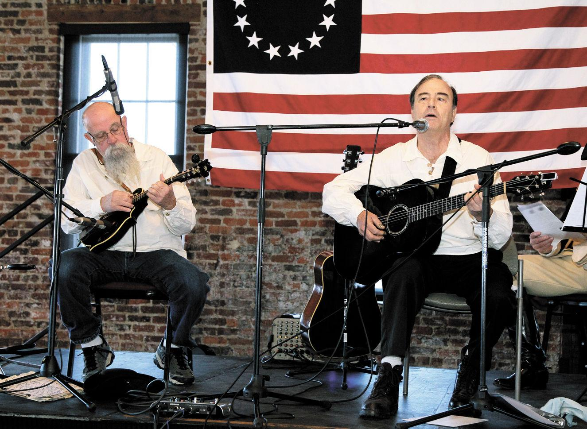
With VASSAR Color Guard leading adjacent states’ Guardsmen, together with the Halifax County JROTC, we marched to Constitution Square where we had a a wreath Laying. Representing the Montpelier DAR is President O’Kelley’s wife Jan (1st on left) with President Jim 4th from the left in Militia attire.
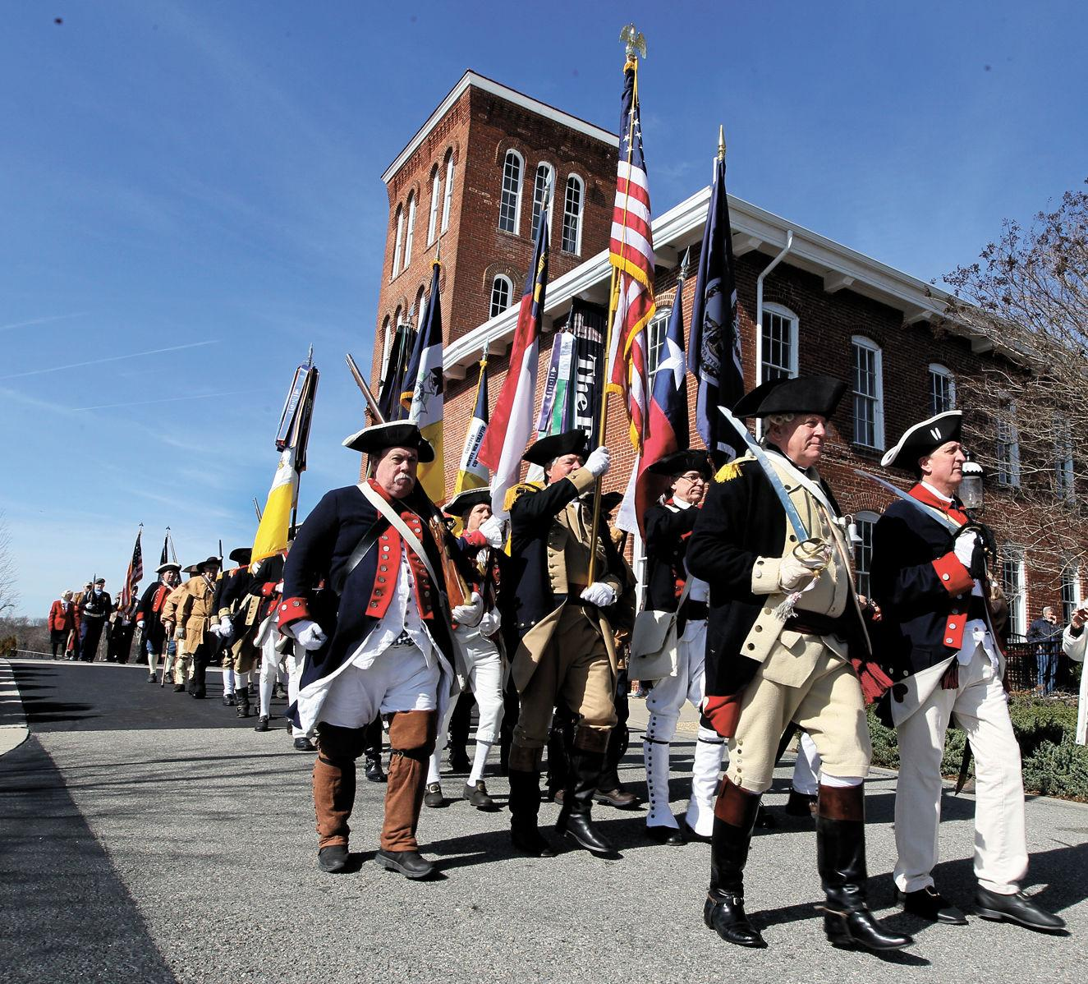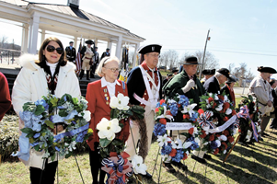
All participants gathered back in the Prizery for Brunswick stew and fellowship.
March 7 Chapter Breakfast
The Chapter was especially honored to have VASSAR new President, Bill Schwetke, join our meeting and delivery an excellent Power Point presentation about the forthcoming NSSAR Congress in Richmond in July. President Jim presented him a “liquid” token of the Chapter’s appreciation for his visit.
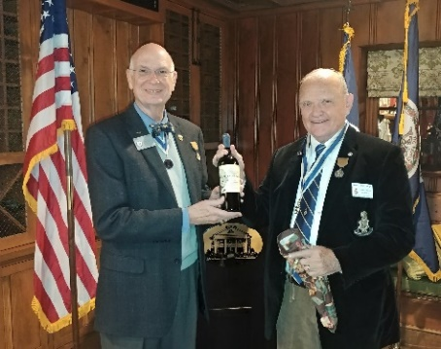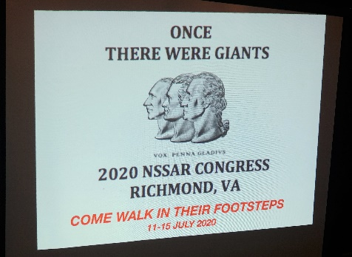
-4-
It is not often that new Compatriots are inducted by the State President. See below, second from the left, are David Hilty, accepting on behalf of his son, David R. Hilty, who lives in New York and second from the right, is Charley Crenshaw. Both had interesting stories to share. Hilty’s son’s ancestor, on his mother’s side, came to America as a Hessian mercenary for the British and changed sides and fought for the Rebels. Crenshaw was sporting on his blazer a Good Citizenship medal awarded him by the Thomas Jefferson Chapter in 1957 when he was a 7th grader at the McGuffey School. Jim and others took time to share various “Opportunities to Serve”, at the Chapter level and at the forthcoming Congress. Pictured at the right is President O’Kelley presenting Chapter Assistant Registrar, John Taylor, with a Supplemental certificate and Gold Star for qualifying his ancestral connection to another Patriot, in addition to the Patriot on whose line he first joined the SAR. The twenty-five Compatriots enjoyed a great meeting.
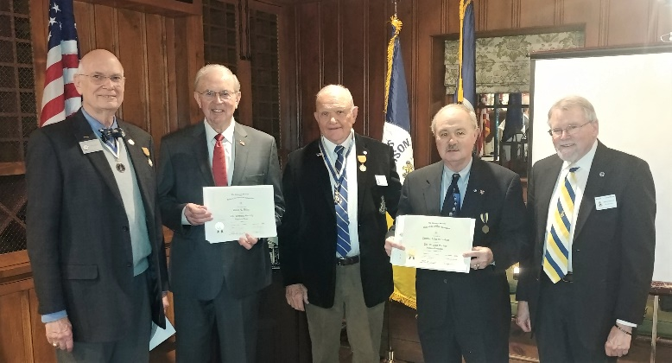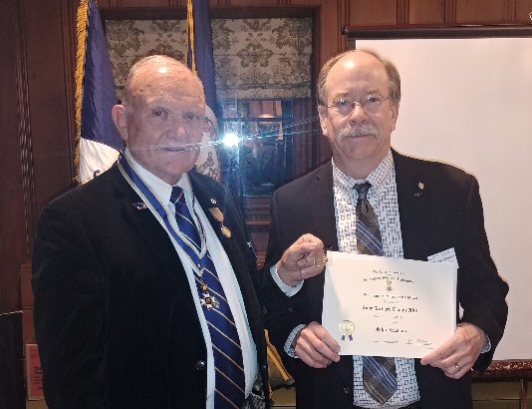
March 14th Battle of Guilford Court House Commemoration – Cancelled
General Greene at the Battle of Guildford Courthouse
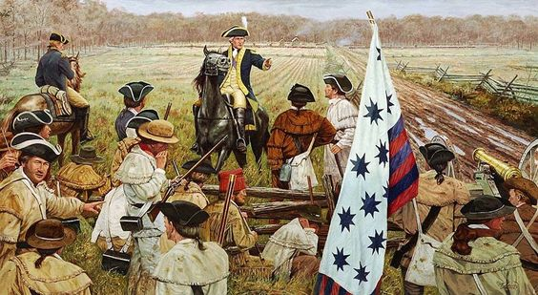
March 16th James Madison’s Birthday Commemoration at Montpelier – Cancelled
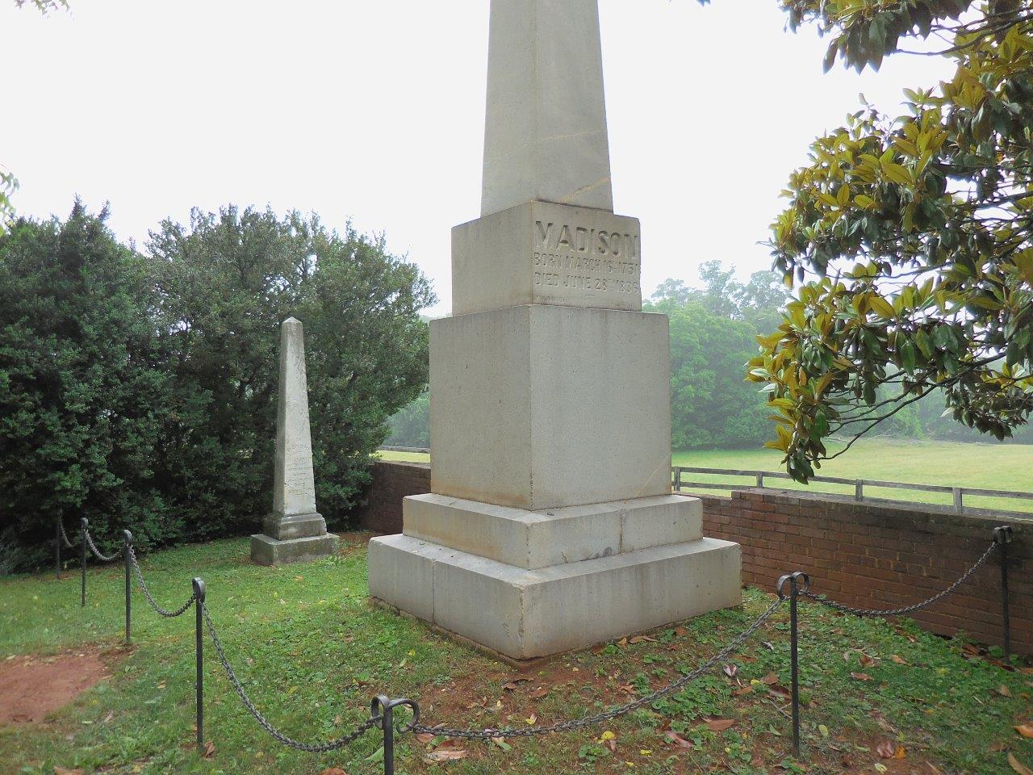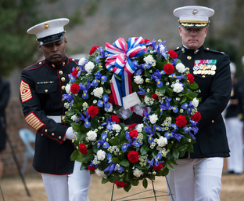
-5-
April 5th – Richmond Chapter-sponsored St. John’s Church “Patrick Henry oration” and Wreath Laying – Cancelled
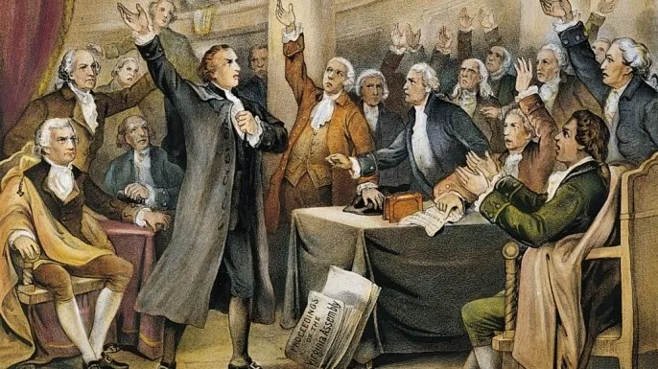
April 6th UVa. ROTC Awards Ceremony – Cancelled
Award recipients for each Service Branch were prepared, together with $100 checks for each winner, and were mailed to the recipients. They are: Certifications for: Midshipman Reed Curtin, Cadet Makayla Bacon (Air Force), Cadets Luke P. McClorey (UVa) and Vanya T. Toll (Liberty)

April 13th Thomas Jefferson Birthday Wreath Laying – Cancelled
Immigration and Naturalization Ceremony (watch here)
https://www.youtube.com/watch?v=GfufmKjodZs

April 18th Graves Mountain Multi-Chapter Event – Cancelled
Sacred Soil Ceremony at Graves Mountain (previous year)
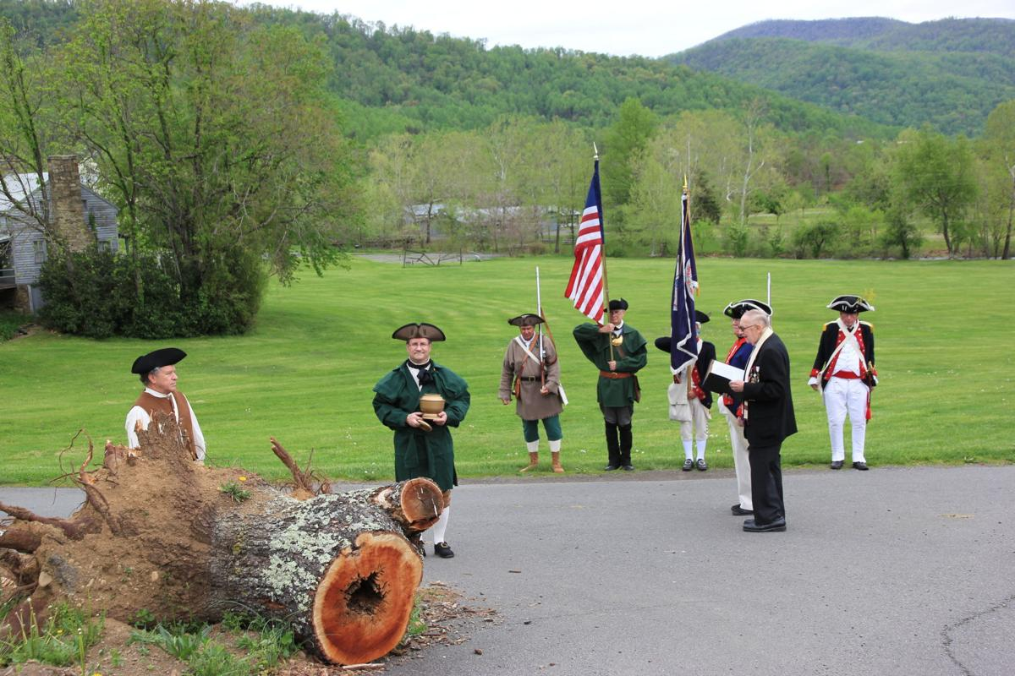
-6-
April 19th Fairfax Resolves Chapter-sponsored Patriots Day – VASSAR President Schwetke Presiding, a National event that included the President General.
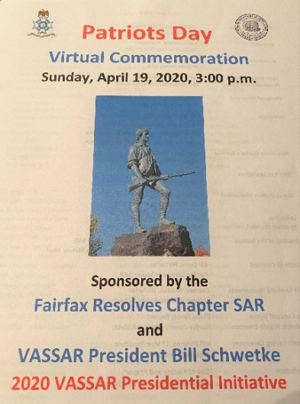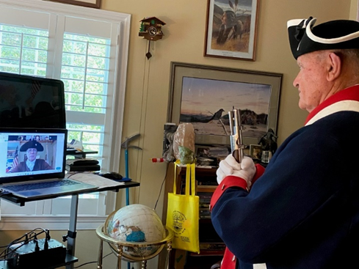
Compatriots might be interested to get a feel for the challenging technical logistics just for the Chapter piece of this. President O’Kelley was in his own home, and his grandchildren were in their respective homes. No small feat.
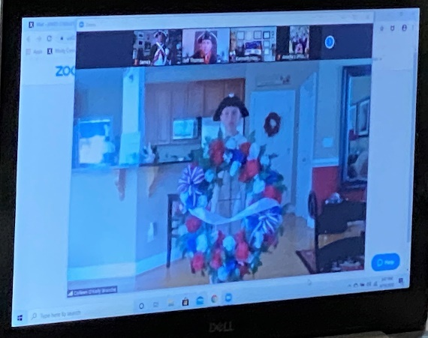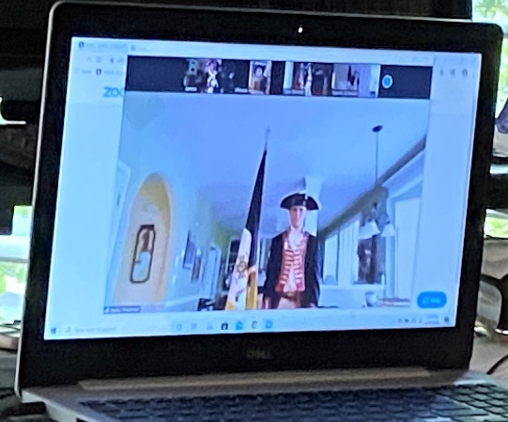

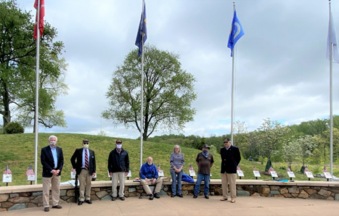
April 24th Vietnam War Memorial Ceremony - Cancelled
But, stalwarts, L to R, Jim Carpenter, Joel Jenkins, Jim O’Kelley, Jim Shisler (Founder), Tom Oakley and Julian Taliaferro, gathered to pay their respects to those who served and those who died, especially those from the Charlottesville area. Chapter President O’Kelley seen presiding below (next page).

-7-
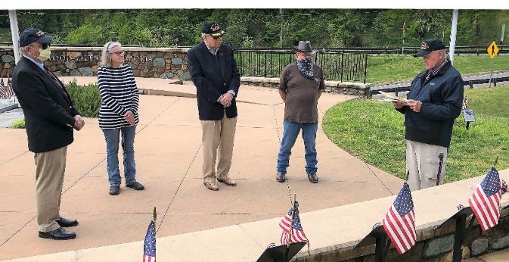

April 26th Notes for Compatriots from Trustee Kelly: VASSAR President Bill Schwetke chaired a ZOOM Virtual Meeting with his Staff and Chapter Presidents this past Sunday afternoon.
Here are the highlights:
All VASSAR officers and 22/29 chapter presidents participated.
Most events for the next three months must be canceled by event organizer to be reflected on VASSAR webpage.
Revised Americanism score sheet will be out soon. by State and National.
Please encourage contributions to Presidential Initiative Mark Brennan, Jr fund.New Membership and Supplemental Applications are being accepted by VASSAR and NSSAR according to VASSAR Registrar Bill Haskins. Chapter Registrars need to be advised of this recent change. Processing at NSSAR is limited but get in the queue! The SAR Patriot Research System (PRS) has a new coordinator, Tim Dioquino, who asks that we encourage participation. Thomas Jefferson Chapter has no participation but a dozen chapters are very active; 40 hours of work qualifies for the Lafayette Medal.
The 4 July Mount Vernon event is being re-planned as a Virtual Event similar to the Patriot's Day 19 April very successful event.
The National Congress scheduled for 10-16 July 2020 is still a go at this time:
150 Hunting Shirts for Volunteers at Congress have been completed and paid for by Peter Davenport.
The Shockoe Monument is in construction and approved by City of Richmond Urban Design Committee.
We reviewed version 13 of 29 March 2020 of the 2020 NSSAR Congress Volunteer Spreadsheet developed by Jim O’Kelley.
The meeting lasted 95 minutes and was very well attended and received.
May 13th Fork Union Military Academy Minuteman Trophy Award
This year’s ceremony will be “Virtual”. These pictures tell the story of so many ceremonies during the COVID 19 pandemic in the spring of 2020. Below pictured are President Jim passing off the award to Sgt. Charlie Coultrie (USMC, ret.) for subsequent virtual presentation to Cadet Xavier White.
-8-
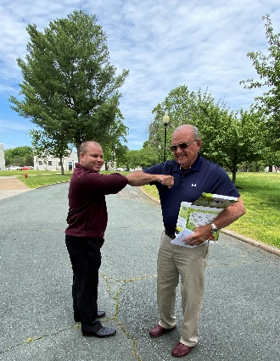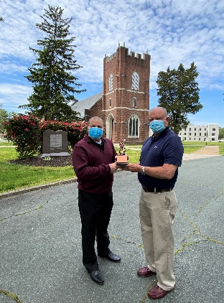
May 16th - Below are the minutes taken by VASSAR Trustee Pat Kelly at a meeting held Saturday, May 16, 2020. Please distribute this to chapter members.
- List of Congress attendees (delegates, President, State Society officers, trustee, and PPGs) must be received at National HQ by June 10. 2. National Headquarters will open for business on this Monday, 18 May. 3. 412 membership applications, supplemental and ancestral applications have been processed, average time was eight weeks. 4. 150 items have been shipped from Merchandise. Item orders received since 15 March are being processed. 5. Received approved Small Business Administration loan for payroll expenditures on 30 April. Two weeks of full pay and one partial week of salaries. 6. Next line of credit wil be requested from 5th 3rd Bank on 1 October. Credit is drying up for LOCs. No obstacles anticipated in securing the LOC. 7. NATIONAL CONGRESS. Still on track for July. Governor's 3 phase plan is the decision point. Mayor of Richmond has requested a delay for Phase 1. NSSAR decision point is 29 May.
Congress registration will not open until 30 May. Some Societies have already seen a drop in attendees due to health concerns, travel/airlines reservations, etc. Concern expressed over taxi sanitation from airport to hotel, Paul will check. No penalty from Marriott or Hilton if Mayor or Governor delay opening plan for the Commonwealth. Hotels are currently on minimum staffing. If only small number of attendees attend, no penalty due to Covid 19 effects. Likewise, if Mayor or Governor announce Richmond stays locked down due to increase in Covid 19 cases, no penalty charge to NSSAR. May have to address use of masks during Congress or other unknown restrictions.
If no Congress in Richmond, 3 options:
A. No Congress
B. Electronic Congress to conduct essential business
C. Live streaming remote Congress--hybrid Congress.
President General stressed the EXCOM is meeting once a week and is/has addressed all contingencies for Congress. 3 June is the final decision day for all contingencies. 8. Next Trustees Meeting is 30 May at 1400.
May 25th Memorial Day – at Williamsburg as celebrated by the Williamsburg Chapter, SAR. Well done fellow Compatriots. This is a moving 8-minute video. Put the link in your browser, and enjoy. [All participants wore masks, until their presentations, and observed distance rules in the cemetery.] https://www.youtube.com/watch?v=ozf95binAO0&feature=youtu.be&t=82
-9-
June 13th – Rededication of the Culpeper Minuteman monument
The Chapter wishes to thank Compatriots O’Kelley and his grandsons Bailey and Blake, the three of whom presented the Chapter Wreath, together with our First Lady Jan presenting the Montpelier DAR Wreath. Below left, VASSAR Trustee Kelly, who presented the French SAR Wreath.
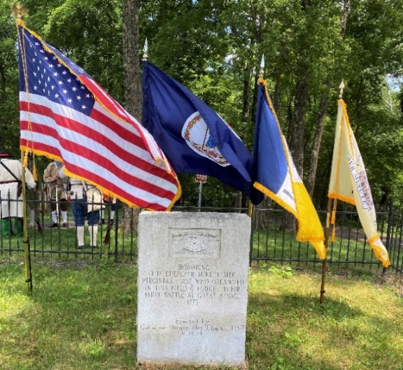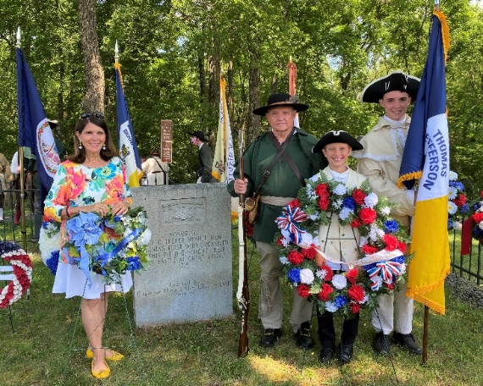

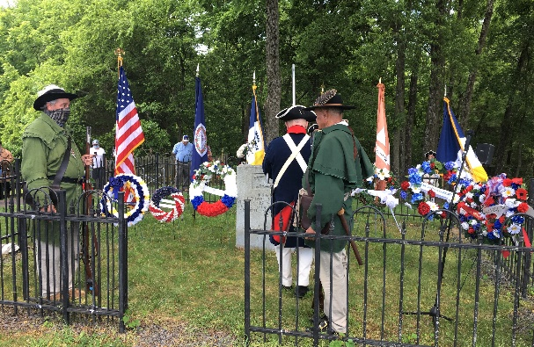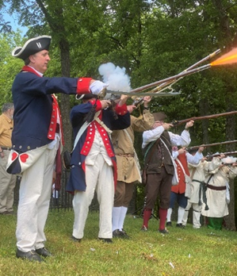

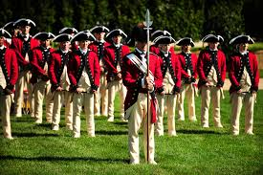
July 4th - Independence Day - Monticello and SAR/DAR graveside ceremonies cancelled.

US Army Old Guard Fife and Drum Corps

-10-
July 4th - Chapter Flag Certificate Presentation
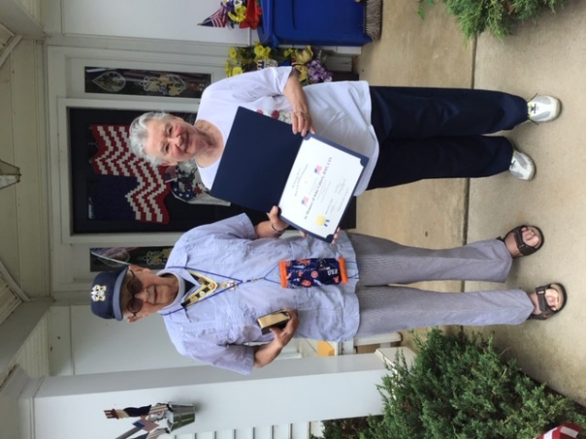
As noted by Compatriot Minich, his Flag Certificate presentation was timely. “This was fortuitous. Jack Valloric's ashes were buried in Arlington on June 23rd of this year with full honors. I read the prayers for Independence Day and for the Navy. Sylvia was thrilled. She changes her flag every flag day and gave me two of her used ones as she cannot get out to the Legion any more. I will deliver them there myself shortly. She usually flies the Navy flag along with the Colors, but put up the Bennington for today. Father Nick Minich.” Well done Compatriot Minich. He was the Chapter’s “Minuteman” this day.

July 4th cont.
TJ Chapter President and his grandson, Blake Branche, were also busy on the 4th serving Color Guard for the “Virtual” 59th George Washington’s Tomb Wreath Laying on Independence Day. George Washington Chapter VP President Roth on left, VASSAR President Schwetke on right. (More pcs in VASSAR section). First Lady Jan O’Kelley presented a wreath on behalf of the Montpelier DAR as well.
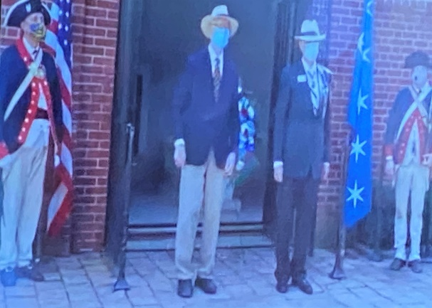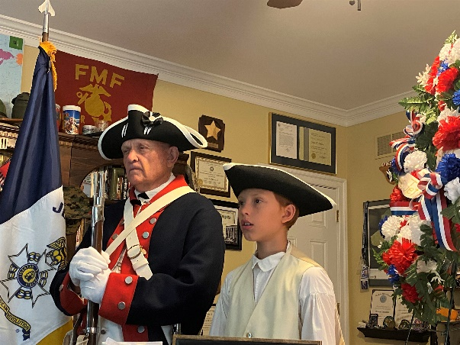
VASSAR NEWS
Feb. 16th – The Crossing of the Dan Commemoration
The Nationally-sanctioned event included a Color Guard Parade and Wreath-Laying (21 SAR, DAR, C.A.R., French Society, SAR, and the Order of Founders & Patriots represented). (Next page)Compatriot Williams is front left. VASSAR Color Guard Commander is at my left, Compatriot Bonner. Second row at the middle are flag bearers VASSAR President Schwetke and and Thomas Jefferson Chapter President O’Kelley.
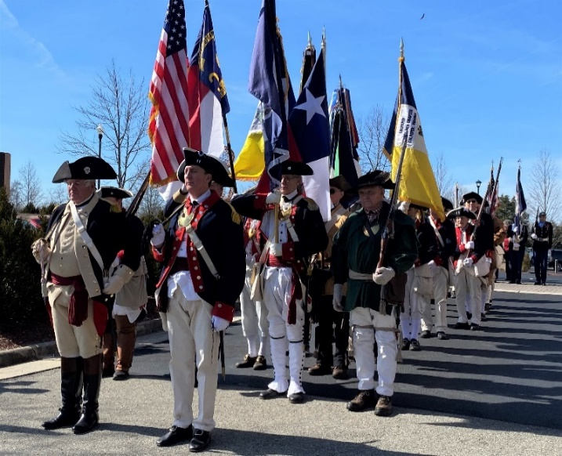
-11-

Below, the Virginia 7th Regiment musket and cannon firing line.
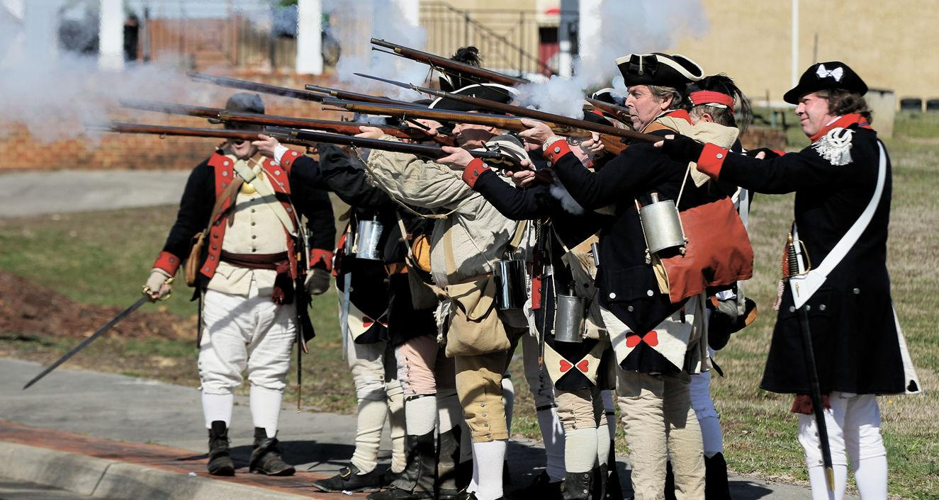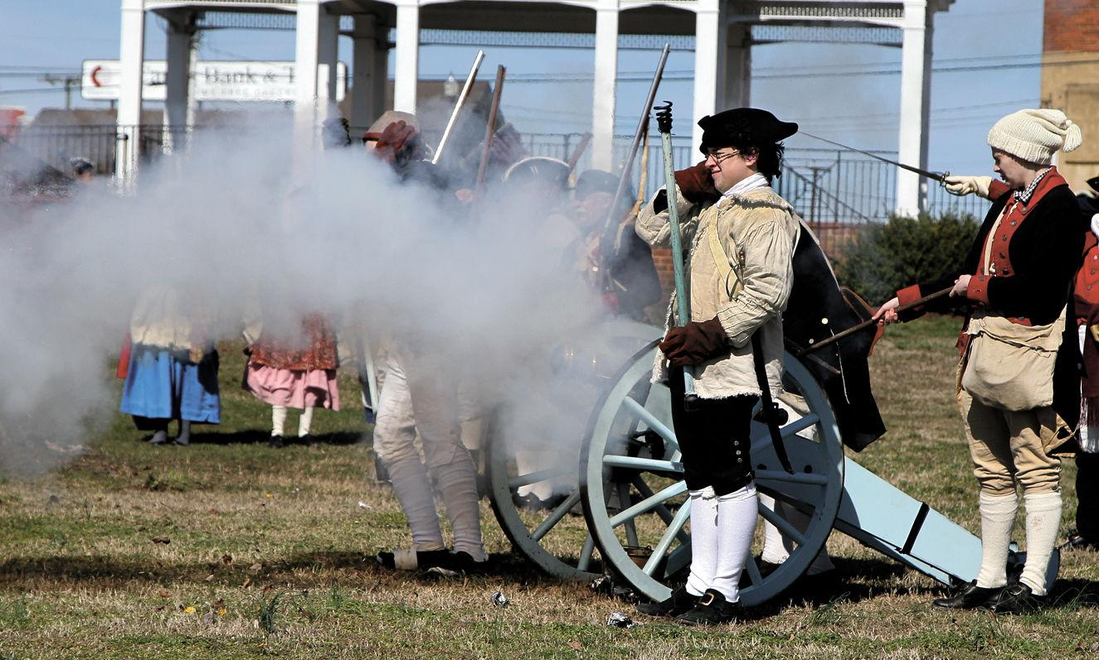
June 13th – Rededication of the Culpeper Minuteman monument
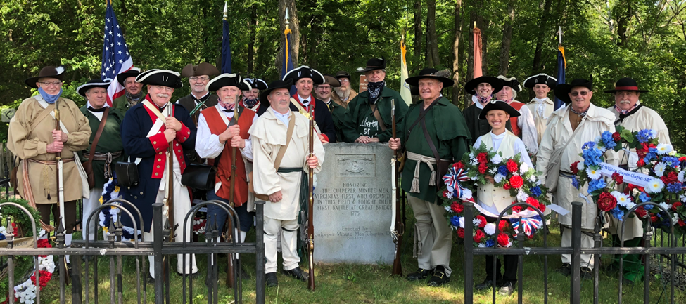
Left to right: Dave Cook, Dale Corey, Michael Dennis, Pat Kelly, Paul Christensen, Clayton Robinson, Leman Duncan, Sean Carrigan, Virginia SAR Color Guard Commander Ken Bonner, Tom Hamill, unknown, Virginia SAR President Bill Schwetke, Jim O’Kelley, Nathaniel Poe, Blake Branche, Eric Robinson, Bailey Friedman, Chip Daniel, Marc Robinson.
-12-
July 4th – The 59th Annual Independence Day Wreath Laying at the Tomb of President and General George Washington. George Washington Chapter VP Tom Roth served as Master of Ceremonies. Remarks were given by GW Chapter President Jay Henn.
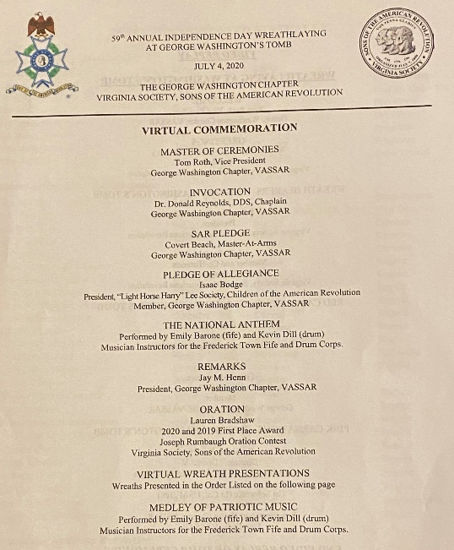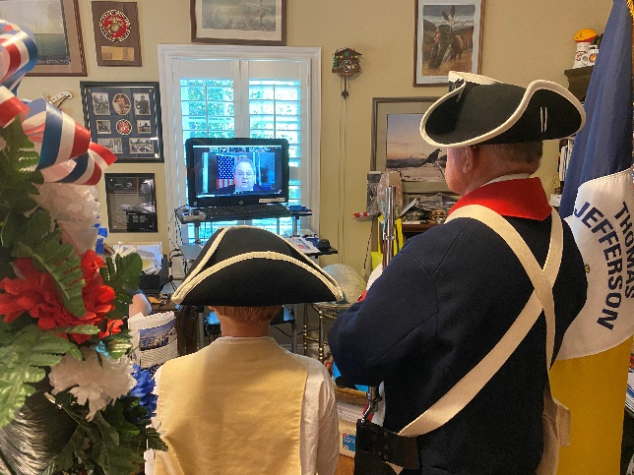

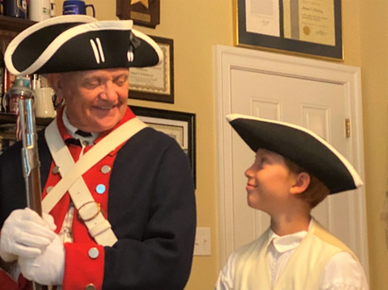
Wreaths Presented: Sons of the American Revolution
Maryland Society, NSDAR Mike Kelley 2nd VP; Col. James Woods, II Chapter Brett Osborn Past President
Col. Wm. Grayson Chapter Leamon Duncan Comdr. Color Gd.; Dan River Chapter Gary Lee Hall President
Fairfax Resolves Chapter David Cook 1st VP; George Mason Chapter Ken Morris President; Thomas Jefferson Chapter James O'Kelley President; Thomas Jefferson Chapter Blake Branche Color Guard
Wreaths were also presented by the Daughters of and the Children of the American Revolution.

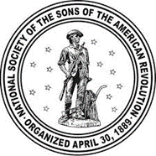 NSSAR NEWS – The National Congress was to have been hosted by Virginia Compatriots. Wonderful plans had been developed over five years. Sadly, it had to be cancelled.
-13-
Critic’s Corner –
First brought to your Publisher’s attention in the SAR Magazine, this book is about Daniel Boone’s wife, children, relatives, and world. It is for adults. It is for young teenagers. Best of all, it is for parents and grandparents to read together with their young teenagers. The ethnographic material and the daunting challenges of life on the American frontier are thrillingly, and chillingly, portrayed by author Sue Ballard. This book follows on nicely the talk that Compatriot Kelly gave us earlier in the year about the Indian wars during the Revolution and beyond, until 1794 and the Battle of Fallen Timbers and the ensuing Treaties of Greenville and Canandaigua which opened up the Ohio River Valley and the Old Northwest Territory to settlement. One cannot but help admire the skills and courage of our forebears who lived on the edge and at the edge of civilization. A hearty lot to say the least. -
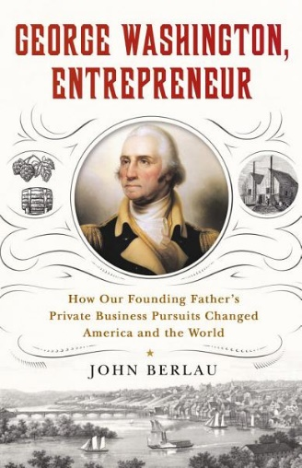
This book provides a fascinating and less well-appreciated insight in to the Father of the Country. Here we see George Washington, not as a planter, but scientific farmer and entrepreneur. As the author notes, “His library was filled with books on agriculture, chemistry, and engineering. He was the first to breed horses with donkeys to produce the American mule. On his estate, he grew countless varieties of trees and built a greenhouse full of exotic fruits and flowers. Unlike his Virginia neighbors who remained wedded to tobacco, Washington planted seven types of wheat. His state-of-the-art mill produced flour which he exported to Europe in sacks stamped GW Flour—one of the very first branded food products. Mount Vernon was also home to a distillery and became one of the largest American whiskey distributors of the era.” The book was just favorably reviewed in the WSJ appearing in the July 4th edition.

NECROLOGY – Thank God the Chapter has no deaths to report year-to-date, the ravages of the Covid-19 pandemic notwithstanding.

OFFICERS – James O’Kelley, President; Geoff Cobham, Secretary and Event Coordinator; David Cooke, Vice President, Joel Strauch, Treasurer, Assist. Treasurer, Mackey Tilman, Rev. Cn. Henry Minich, Chaplain; Mark Chapman, Registrar; Pat Kelly, Historian; Harvey Hague, Chancellor; Dr. Ken. Wallenborn, Surgeon; Phil Williams, Publicist, and Joseph Garland, Photographer.

-14-
BOARD OF MANAGERS – Compatriots O‘Kelley, Tilman, Cobham, Kelly, Wallenborn; Williams; Minich; Hague; Chapman, Strauch, J. Garland, Emeritus: Lea Schultz.
COLOR GUARD - P. Kelly (Chair), M. Day, K. Wallenborn, J. O’Kelley, P. Williams, B. Friedman, B. Branche

COMING EVENTS
Aug. 23 Annual Garden Party – At the home of First Lady Jan and President Jim O’Kelley’s home, featuring Mission BBQ and a chance to come together. Face masks and distancing are appropriate for those who wish. Lots of space from the house to the balcony and the garden. Begins at 5:00.
Sept. 3 BOM, 4:00
Sept. 12 VASSAR Semi-Annual, Halifax County
Oct. 3,4 Battle of Point Pleasant, Battle of Kings Mountain – Nationally-reconized events.
Oct. 10 Chapter Breakfast, Pine Rm, Farmington
Oct. 19 Yorktown Commemoration
Nov. 11 Veterans’ Day ceremony, County Office Building, 11:00
Dec. 5 Chapter Christmas Luncheon with Ladies, Greencroft, 11:30 Social, 12:00 Luncheon
Dec. 12 Wreaths Across America – Dogwood Vietnam Memorial, 12:00, Monroe’s Highland, 1:00
