THE JEFFERSONIAN GAZETTE
THOMAS JEFFERSON CHAPTER
FALL ISSUE – 2018
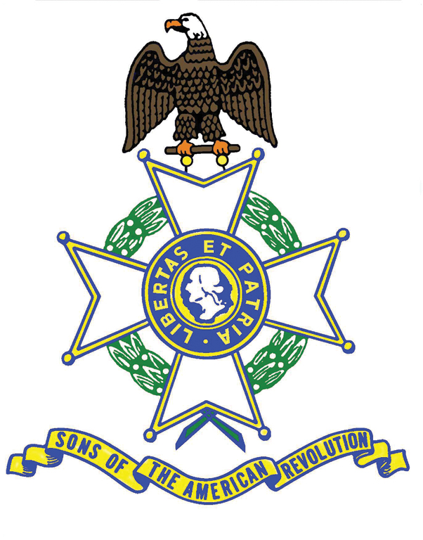
President’s Message
Fellow Compatriots, the Summer and Fall have flown by. We have been very “SAR-busy”. I thank you for giving Jan and me the opportunity to represent you and our Chapter at so many interesting and educational events—worldwide! The majority of the events we attended are covered in the Gazette. They range from the SAR France trip to our recent Grave Marking in Scottsville. Our grandson Bailey will qualify for his Bronze Color Guard Medal this year so we are getting younger members involved. Please encourage your children and grandchildren to participate with us. Thank you for supporting our Thomas Jefferson Chapter of SAR and have a safe and Happy Holiday Season.
Semper Fi, Jim O'Kelley
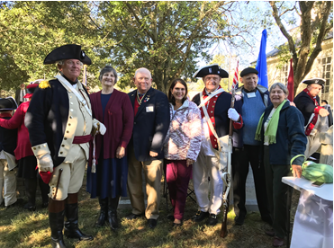
[Yorktown, Thomas Nelson Gravesite, Pictured L to R, Compatriots Williams, Kelly, O’Kelley, Garland – Ladies, L to R, VASSAR First Lady Jennifer Kelly, Chapter First Lady Jan O’Kelley, Martha Garland. Compatriot Nelson not in Pc.]
-2-
PAST EVENTS
June 10-20
At the invitation of SAR France, some 40 US Compatriots traveled to France to commemorate the Centenary of the signing of the Armistice ending the Great War. For the Kelly’s, O’Kelley’s, their DAR daughter, Tara Friedman and your Publicist, it proved unforgettable experience.
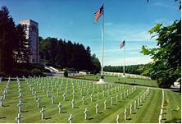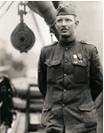
Aisne-Marne Cemetery Sergeant Alvin York
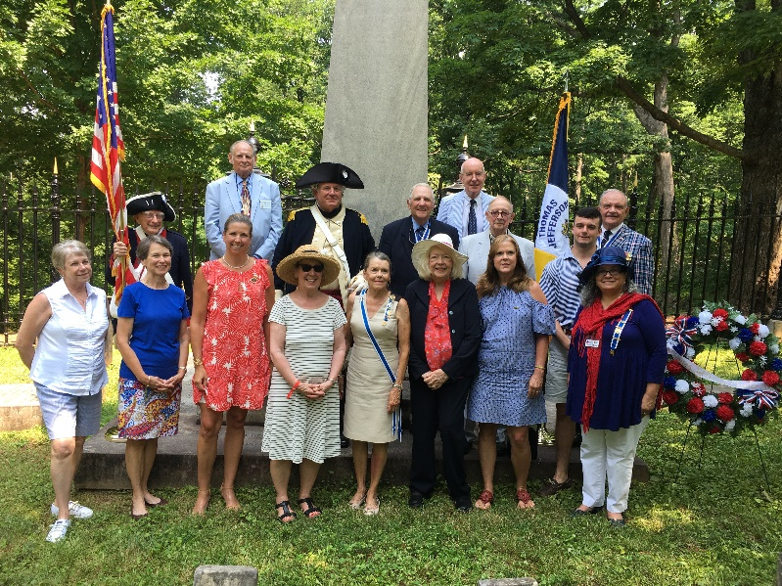
July 4

Keynote Speaker Father Minich’s remarks at the joint Jouett/Thomas Jefferson gravesite ceremony concerning Jefferson’s Christianity were inspired, particularly in light of more “fashionable” revisionism on the subject. Pictured here here with us, our DAR sisters.

Aug. 10,11 The Chapter thanks Compatriots Kelly, O’Kelley, Williams and their wives for representing VASSAR and the Chapter in Newport News at the Atlantic Middle States District conference. Attendees were treated to a fascinating tour of historic Jamestown, where modern forensic science is adding greatly to understanding the oft’-harrowing lives of our Colonial ancestors. Sturdy stock for sure.

-3-
Aug. 18
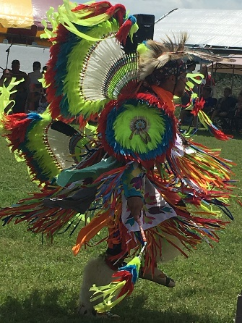
VASSAR now has 28 Chapters, the newest being the Nansemond Indians Patriot Chapter. Pictured here in Militia attire are, President O’Kelley and VASSAR Color Guard Commander and VASSAR 2nd VP, Bill Schwetke. VAASAR President Kelly also in attendance at the Pow Wow. 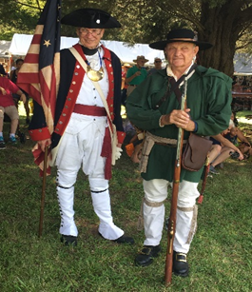
Sept. 8
VASSAR President Kelly, Chapter President O’Kelley and Compatriot Friedman, as Color Guard, attended, with President General Warren Alter, an SAR wreath laying ceremony at the Tomb of the Unknown Soldier, Arlington Cemetery.
Sept. 9
The Compatriots and their wives were graciously hosted by Sima and Gerald Brown. Highlights included homemade Iranian dishes, the induction of Compatriot Williams’ nephew, Andrew Holmes (pictured with his parents), and Compatriot awards given by Past Chapter Presidents Kelly and Tilman to Compatriots Cobham and Williams.

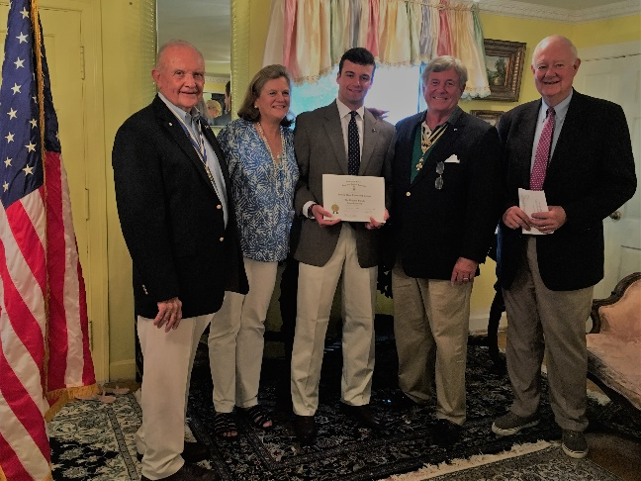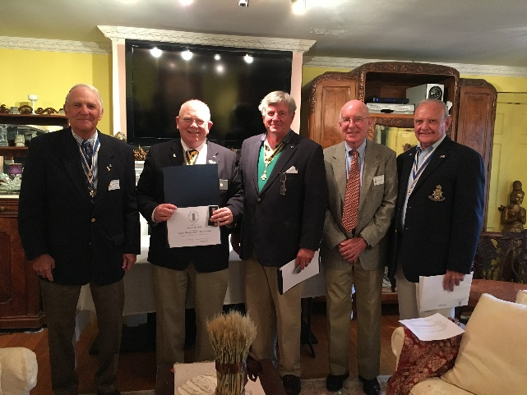

-4
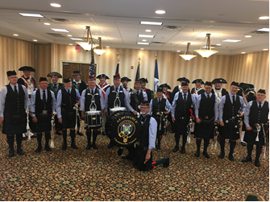
Sept. 14,15

The Thomas Jefferson Chapter hosted the Semi-Annual. Members of particular note who especially contributed to President Kelly’s spectacular event included Messrs. O’Kelley, Cobham, Tilman, Cobham, Garland, Wallenborn, and Williams. They were ably assisted by First Ladies Jennifer/VASSAR and Jan/Thomas Jefferson, and Beth Cobham.

Oct. 6
The Chapter Breakfast was a great success in no small measure due to a memorable power point and video presentation by President O’Kelley’s daughter, Tara Friedman, regarding the Armistice Centennial SAR trip to France, together with First Lady Jan’s extraordinary Chapter Scrapbook covering the same and so much more. President O’Kelley also took great pleasure in presenting Compatriot Brown a Certificate of Appreciation for his and Sima’s generous hosting of the Chapter Picnic in September.

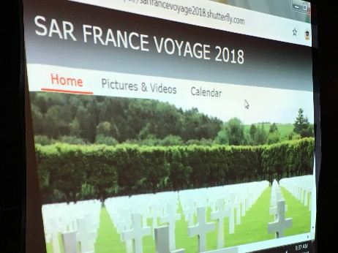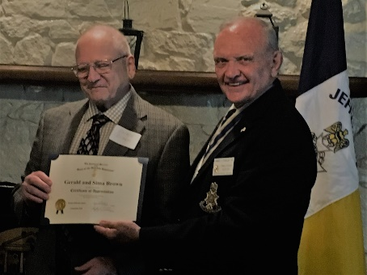

-5-
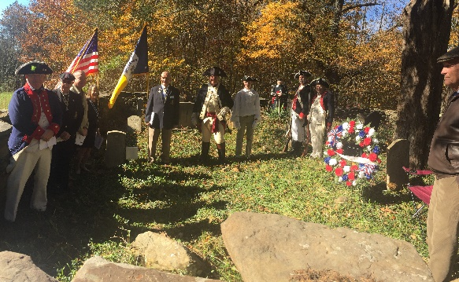
Nov. 3
Organized by VP Cooke, presided over by President O’Kelley, and officiated by Father Minich, the Chapter marked the grave of Capt. Benjamin Harris, of the Virginia Continental Line, who served both at the Barracks and with General Lafayette at Yorktown. Compatriots Tilman and Williams joined in the ceremony with VADAR Regent Judith Surber, and Jouett and Albemarle Regents Sharon Boyer and Gretchen Kelly. Compatriots Day, Kelly and Wallenborn served as Color Guard and Musket salute team. Special mention goes to our youngest member, Bailey Friedman, who did the unveiling of the marker and our Piper, Compatriot Chapman.
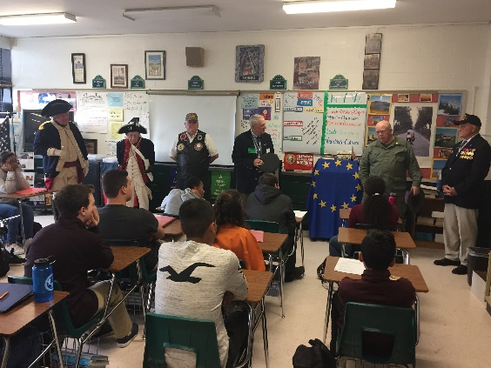
Nov. 7

Compatriots are seen here at Wm Monroe High School at the invitation of Tara O’Kelley Friedman, French teacher, and the School Principal, Katie Brunelle, addressing the students on the significance of Veterans’ Day and its historical relationship to Armistice Day of exactly 100 years ago.

Nov. 11
The Chapter wishes to thank Compatriots O’Kelley and Wallenborn (Chapter wreath), Williams (VASSAR wreath), for attending the Charlottesville American Legion-sponsored Veterans’ Day ceremony.
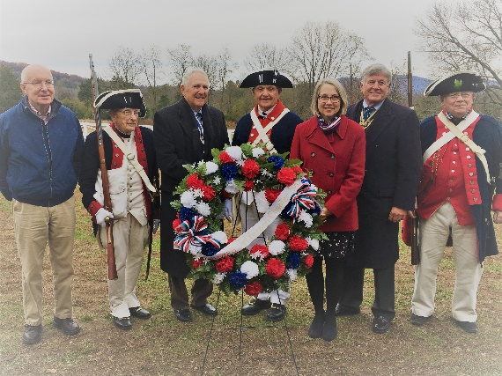
Nov. 12
At President Monroe’s Highland, Compatriot O’Kelley gave the keynote address about President Monroe the soldier, the Minister, the President. He spoke eloquently of America’s Veterans from the Revolution to the present and in the future who stand sentinel for the freedoms we sometimes take for granted. He is pictured here with Compatriots Cobham, Wallenborn, Tilman, Highlands’ Executive Director, Sara Bon-Harper, Williams, and VASSAR President Kelly. The ceremony included the University of Virginia ROTC Color Guard, and the Buford Middle School Band.
Dec. 1 The Annual Ladies Holiday luncheon was a great success, featuring VA C.A.R. President Molly McCue, who spoke eloquently of their State Project related to the forensic conservation studies of the King
-6-
Carter home, followed by Army ROTC Lt. Colonel Montgomery, MSG Clancy and Cadet England, whose messages about Virginia’s and Liberty College’s programs to train the next generation of America’s military leadership, were both encouraging and reassuring. The Chapter honored with the Lydia Darragh medal in recognition of the extraordinary contributions to the both the Chapter and VASSAR of its First Lady, Jan O’Kelley. Vice President Cooke was recognized for his contributions to the Awards Program and spearheading the Chapter’s first Patriot Grave marking in a decade with the Roger Sherman medal. Compatriot Strauch was recognized with the Meritorious Service medal for his seamless transition into the role of Treasurer. President O’Kelley, for outstanding and extraordinary leadership contributions as President and Color Guardsman, at both the Chapter and VASSAR levels, was awarded the Distinguished Service Medal, an award that is typically only given after years of invaluable service. He, and his Co-Pilot Jan, are only one year in and earned it in spades. Huzzah! And finally, the Chapter’s VASSAR-supported Law Enforcement award went to Commonwealth Attorney Robert Tracci, who delivered a moving testimonial to the “Spirit of ‘76”, including quotations from Judge Learned Hand and President Reagan. He spoke reverentially about Founding Fathers Washington, Jefferson and Madison, noting as a first generation American, “But every American – regardless of lineage, race, religion, ethnicity, or national origin – is a Son and Daughter of the Spirit and Promise of the American Revolution. And the work and legacy of this organization [SAR] have helped secure the freedom, liberty, and equality of opportunity that are the birthright of every American”. Thank you to those Compatriots who brought presents for the Veterans in the Spinal Cord Injury Unit of the VA Hospital in Richmond.
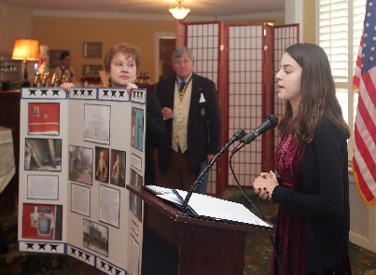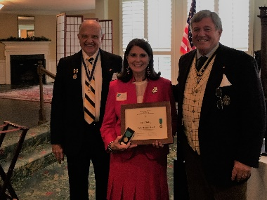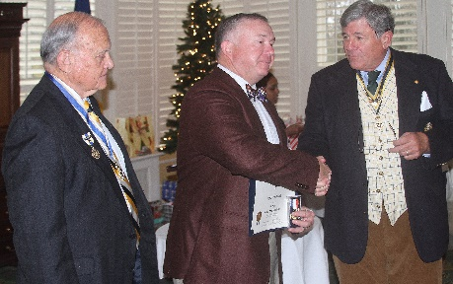
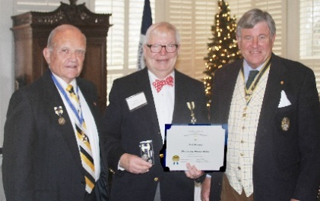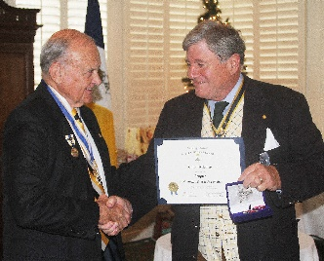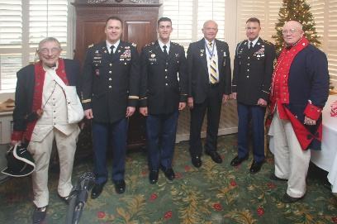
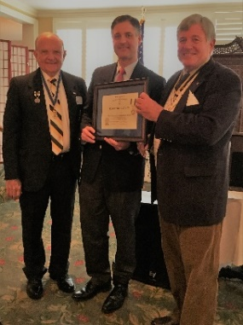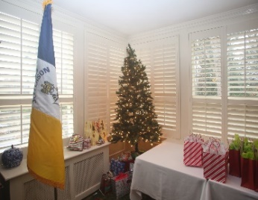
-7-
VASSAR NEWS
Our Past Chapter President, now VASSAR President Patrick Kelly, and VASSAR First Lady Jennifer Kelly, are nearing the end of a banner year, that has taken them from France, to the District of Columbia, Kentucky, the Carolinas, Tennessee, West Virginia, and all over the Commonwealth. They have done the Thomas Jefferson Chapter proud indeed.
NSSAR NEWS – National will meet in California in July -10 of 2019 in Costa Mesa, California.
Wreaths Across America
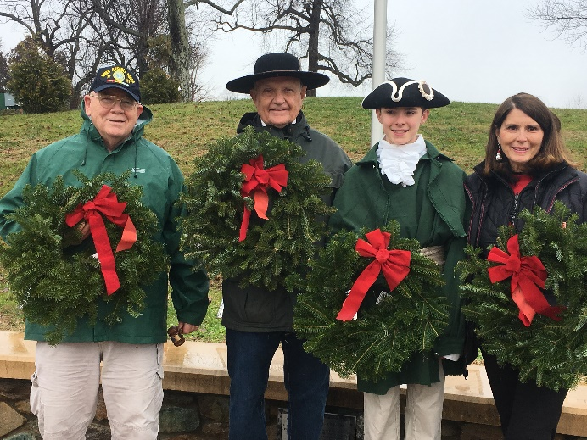
The rain held off just long enough on Dec.15th for Compatriots Kelly, O’Kelley, Bailey Friedman and First Lady Jan O’Kelley, representing VASSAR/TJ SAR/ in this NSSAR Observance commemoration. In the words of NSSAR Veterans Recognition Chair Walt Timoschuk III (TNSSAR), “I want to personally thank all the Civil Air Patrol members, Girl Scouts, Boy Scouts, Young Marines, American Legion, American Legion VFW Auxiliary VFW, VFW Auxiliary, Disabled Veterans, N.S.S.A.R. members, N.S.D.A.R. members C.A.R. members families, children that participated in supporting Wreaths Across America. Wreaths Across America held its annual day of tribute on Saturday, honoring veterans by placing holiday wreaths at gravesites in more than 1,400 cemeteries across the nation. This year over 1.5 million wreaths were placed by volunteers on the graves and out of respect for our fallen and all the veterans that have made this country great.”
NECROLOGY – Robert Bruce Rogers, Jr., Robert Leith Vestal French, Charles Floyd Mapp.
OFFICERS – James O’Kelley, President; Geoff Cobham, Secretary and Event Coordinator; David Cooke, Vice President, Joel Strauch, Treasurer, Assist. Treasurer, Mackey Tilman, Rev. Cn. Henry Minich, Chaplain; Mark Chapman, Registrar; Pat Kelly, Historian; Harvey Hague, Chancellor; Dr. Ken. Wallenborn, Surgeon; and Phil Williams, Publicist.
BOARD OF MANAGERS – Compatriots O‘Kelley, Tilman, Cobham, Kelly, Wallenborn; Williams; Minich; Hague; Chapman, Strauch, Hiss. Emeritus: Lea Schultz
COLOR GUARD - P. Kelly (Chair), M. Day, K. Wallenborn, J. O’Kelley, P. Williams

-8-
COMING EVENTS (MARK YOUR CALENDARS for 2019)
Jan. 10 BOM at AMVEST, 4:00 Feb. 8,9 VASSAR Annual Meeting, Richmond Feb. 15,16 The Crossing of the Dan – a NSSAR-sanctioned observance
March 2 Chapter Breakfast, Pine Room, FCC, 8:45
March 16 James Madison Birthday at Montpelier, wreath laying – Guildford Ct. House/NSSAR Event April 13 Thomas Jefferson Birthday at Monticello, wreath laying April 26 Dogwood/Vietnam Memorial Ceremony, 11:00
April 27 Graves Mountain – Multi-Chapter Luncheon
May 2 BOM at AMVEST, 4:00 May 11 Raid on Martin Station, Cumberland Gap – a NSSAR-sanctioned observance May 27 Memorial Day, at Pavilion, wreath laying
June 1 Chapter Breakfast, FCC, Ladies Invited, 8:45
July 4 Monticello Naturalization Ceremony, 9:00 - Joint Jack Jouett-TJ at Jefferson at graveside, 10:45 Sept. 5 BOM at AMVEST, 4:00
Sept. 8 Chapter Garden Party, Ladies invited, 4:00, Venue TBD
Sept. 13,14 VASSAR Semi-Annual
Oct. 5 Chapter Breakfast, FCC, Pine Room, 8:45
Oct. 19 Yorktown Observance – a NSSAR-sanctioned observance Nov. 7 BOM at ADVEST, 4:00 Nov. 11 Veterans’ Day ceremony at the Pavilion, 11:00
Dec. 7 Chapter Holiday Luncheon with Ladies, Greencroft, 11:30 Social, 12:00 Luncheon
Dec. 14 Wreaths Across America – a NSSAR-sanctioned event
