THE JEFFERSONIAN GAZETTE
THOMAS JEFFERSON CHAPTER
SPRING ISSUE – 2019
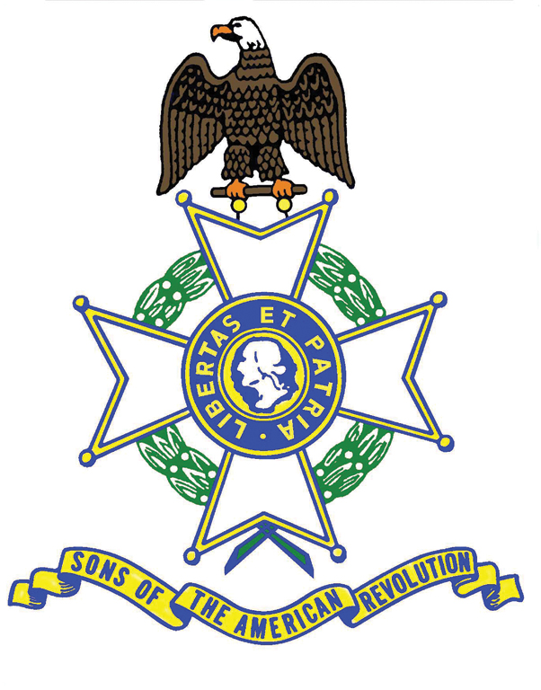
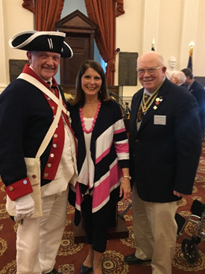
President’s Message

Fellow Compatriots –The 2019 SAR event season began with the VASSAR Annual Meeting on 8-9 February in Richmond. The report on that follows. Our Chapter First Lady, Jan, is pictured here in the Senate Chamber of the State Capitol with outgoing VASSAR President Pat Kelly, receiving the State Award for the best Chapter Scrapbook. This is the first time our Chapter has ever won this award. Officially, I accepted the Award and Banner on behalf of our Chapter, but it was her extraordinary labor of love and the contributions of many of you that made this honor possible. She has traveled with me to countless events, across Virginia and many other States and France, in my first year as Chapter President. I hope you all will join me in thanking her for her dedication to the Chapter and the SAR.
Since the Chapter was founded in 1939, we have now sent eight of our distinguished members to serve as State President. They include: Col. Carol Wright; Charles R. Haugh; Thomas P. Nelson; Howard Hamilton; Trice Taylor; Phil Williams, and Pat Kelly, who stepped down at this event. Pat, and First Lady Jennifer, have now added admirably to that venerable Chapter tradition.
I have enjoyed working with all of you this past year and Jan and I look forward to another great year of contributions and Opportunities to Participate. The Gazette contents speak to the continued good works of the Thomas Jefferson Chapter. I encourage each of you to participate and enjoy as many events as you are physically able to attend. Encourage your sons and grandsons to participate with you! They are our future and we need to educate them about our ancestors’ sacrifices for the freedoms we all enjoy. Thank you for allowing me to continue to serve as your President. Semper Fi, Jim O’Kelley
-2- PAST EVENTS
FEB. 8,9 VASSAR Annual General Meeting, Richmond, Virginia
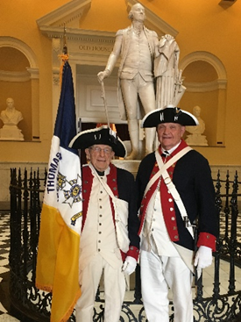
The Chapter received five event participation streamers: Participant Vicars Grave Marking Ceremony Russell County 2018; Rev. War / War 1812 Plaque Dedication Lynchburg 2018; Participant Night at the Ballpark 2018; Contributor 116th Infantry Museum 2018; Contributor VASSAR Brennan Fund 2018 (Youth Awards Program), and winner of the Chapter Scrapbook competition – thanks to Chapter First Lady Jan O’Kelley. Compatriot Color Guardsman O’Kelley and Wallenborn share the spotlight with Mr. Jefferson in the State Capitol.

FEB. 15,16 The Crossing of the Dan, South Boston, Va. – a NSSAR-sanctioned observance
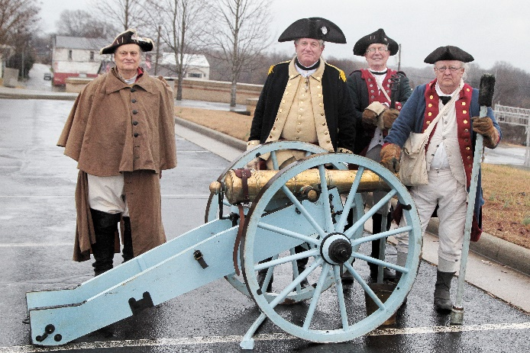
The Chapter would like to thank VASSAR Trustee Pat Kelly, who presented wreaths for the Chapter and the French SAR Society and Phil Williams who served, for the fifth year, as the ceremony’s MC. He is seen here with the 7th Virginia Regiment of Continentals, 4-Pounder canon crew and Militia firing lines on a rainy day with the river too high to reenact the Crossing. Mark Anthony, the NSSAR Color Guard Commander, together with VASSAR CG Commander Bill Schwetke, led a large group of Guardsmen from Georgia, South Carolina, North Carolina, Ohio, Virginia and Maryland (Lou Raborg who is also the AMS District Vice President General and brought the PG’s Greetings). VASSAR was represented by its new President, Judge Peter Davenport. The Dan River Chapter did a splendid job organizing the event in coordination with the Berryman Greene Chapter of the DAR.
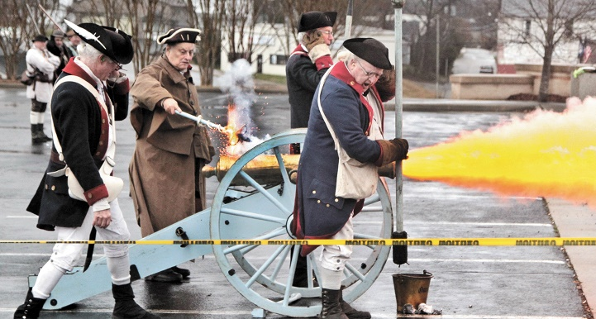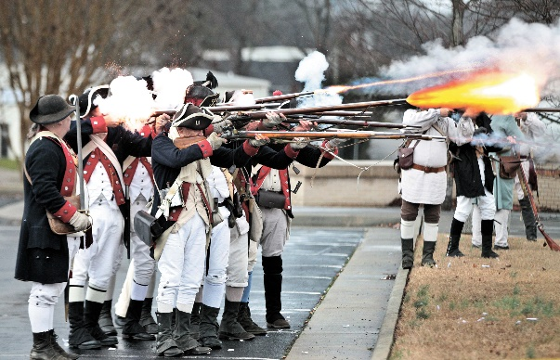

-3-
FEB. 23 President O’Kelley is to be thanked for presenting the Chapter Wreath, while also serving with the VASSAR Color Guard, near Colonial Beach/Fredericksburg, at the commemoration of the signing of the Leedstown Resolves in 1766, a protest against the Stamp Tax.
March 9 On a snowy morning, with the fire burning in the Pine Room at Farmington Country Club
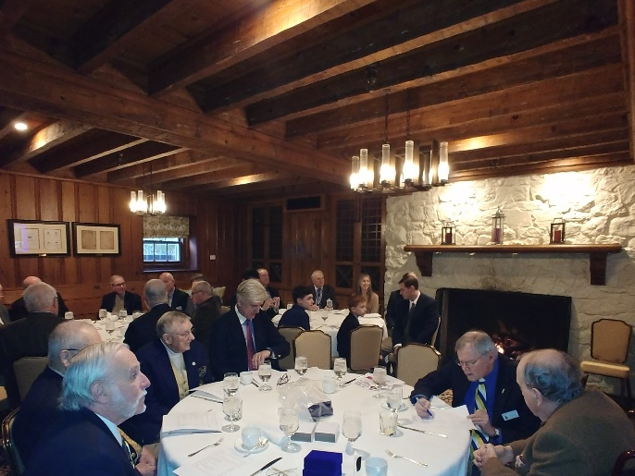
we were treated to an excellent program. It began with the induction of new member David Gibson (l to r. President O’Kelley, Inductee Gibson, Registrar Chapman, and Immediate Past VASSAR President Kelly.
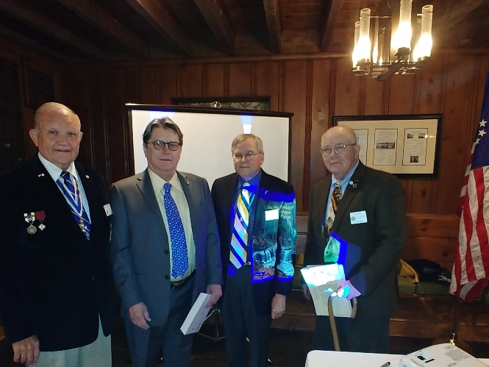

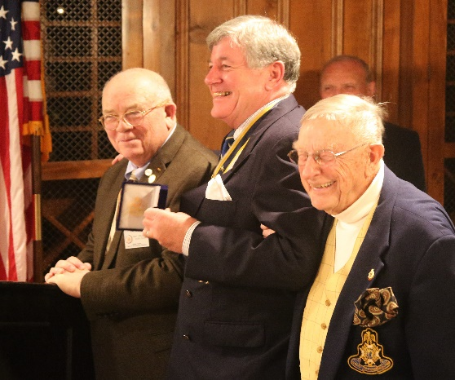
Pat Kelly also presented distinguished service awards to Compatriots Wallenborn and Williams, (pictured here), and Cobham.
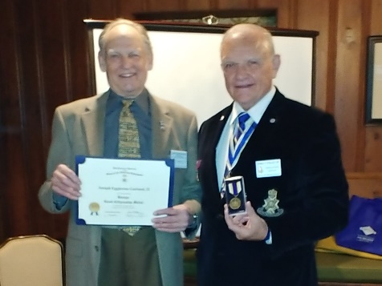
Chapter President O’Kelley recognized Compatriot Garland with a Bronze Good Citizenship Medal for his service as Chapter

Photographer in recent years.

-4-
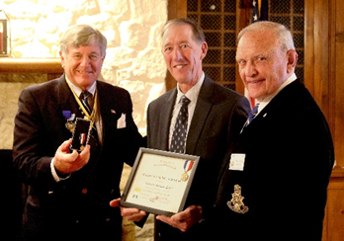
Dr. Douglas Cox was honored for his many contributions to the Veterans with the Veterans Service Award. He has donated and raised a considerable amount of money for various Veterans’ causes.
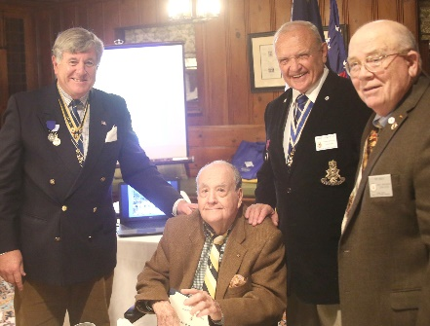
Past Chapter President Jim Parrish was recognized with a 50 -Year SAR Membership pin.

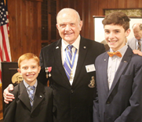
Getting young people involved, President O’Kelley invited his Compatriot grandchildren.

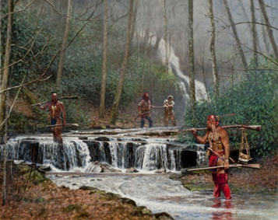
The attendees were also treated to a penetrating examination by Compatriot Kelly of the ferocity and significance of the Indian wars, Cherokee and Shawnee in particular, and the crucial role played by the Virginia, Tennessee and Carolina militias in driving the British toward Yorktown and their final defeat. Pictured at left is Steve White’s painting of Shawnee, note their red and black traditional face paint, and two frontiersmen held as prisoners.
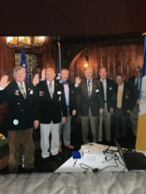

Past VASSAR President Kelly inducted Chapters Officers ( l to r) Williams, O’Kelley (President), Cooke, Tilman, Cobham, Wallenborn and Strauch. Registrar Chapman was there but not in picture. Officers Minich and Hague were not present.
Gentleman – the Board is looking for you. If you are interested in helping and taking some responsibility for the Chapter and its management, please approach anyone of the current members. Some of our BOM members have served 15 and 20 years. We need and welcome your help, your energy, and your ideas.
-5-
MARCH 16th proved to be a busy day for TJ Compatriots. Compatriots O’Kelley, Kelly, Day and Wallenborn represented the Chapter and VASSAR at the commemoration of the Battle of Guilford Court House in Greensboro. The second picture features Dr. ken and President Jim with President General Warren Alter. Pictured in front of the grand equestrian statue of General Greene are on the far right Compatriot Wallenborn, and moving left, Compatriot Day, VASSAR President Peter Davenport, Chapter President O’Kelley, and far left, VASSAR CG Cmdr. and Ist VP Bill Schwetke.
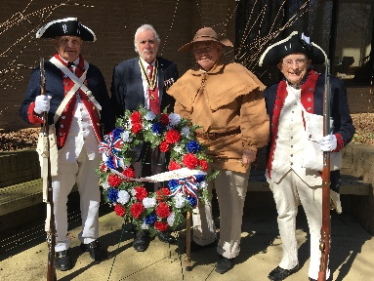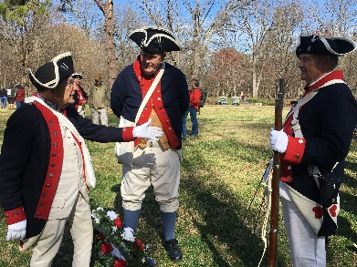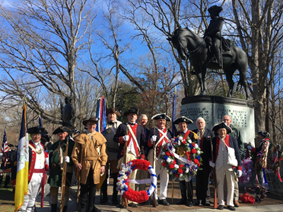
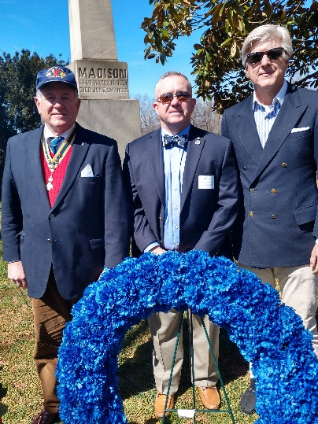
On the same day, VP Cooke presented the Chapter wreath at Madison’s birthday commemoration at Montpelier. He was joined by Compatriot Williams and prospective member William Calary. The number of VASSAR Chapters has grown in recent years. In addition to Thomas Jefferson, they included Col. Wm Grayson, Culpeper Minutemen, Fairfax Resolves, Richmond, and Williamsburg. The brief remarks by Commander William Bentley, U.S. Marine Corps Installations, National Capital Region, Quantico were excellent and the remarks by 30th District Virginia House Delegate Nicholas Freitas were moving, noting that the fine clay of American political leaders is no better than that of America’s citizens who must be vigilant that government does not overstep its bounds, a principle that Madison and other Founders enshrined in the Constitution.
APRIL 2 Maury Hall at The University was the venue for the annual ROTC Awards. The Chapter thanks Compatriots O’Kelley, Minich and Wallenborn, who presented tha Army, Navy, and Air Force Cadet Winners with Silver Medals, Certificates, and checks for $100 for their achievements. Assisting in the
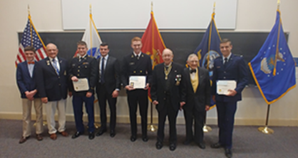
presentations were younger Compatriots Bailey Friedman (President O’Kelley’s grandson)) and Andrew Holmes (Compatriot Williams’ nephew).

-6-
APRIL 12 Thomas Jefferson Birthday at Monticello APRIL 26 Dogwood-Vietnam Memorial Ceremony
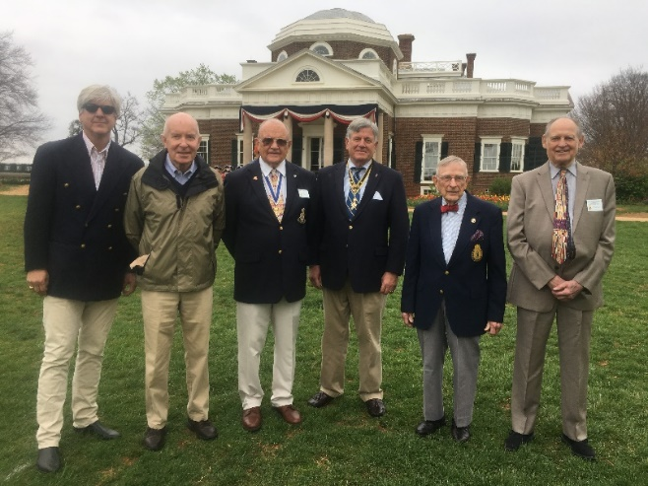
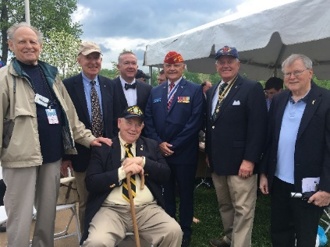
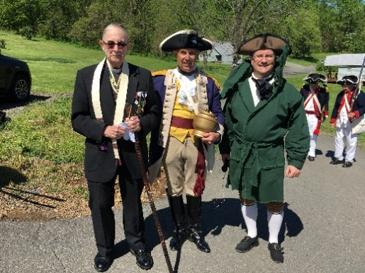
APRIL 27 Graves Mountain – Multi-Chapter Luncheon
The event began outdoors with Chaplain Minich officiating over the collection of Virginia soil to be spread at the site of the Battle of Waxhaw’s to cover the Virginia Patriots buried there in S. Carolina. The picture below attests to the excellent showing of the Color Guard. Past VASSAR President presented Compatriot O’Kelley with a Virginia Society State Service Medal Award. Not pictured, but Compatriot Williams received an Oak Cluster for his Virginia Society State Service award. The ladies then stole the show, beginning with Jan O’Kelley who received three different awards including two Certificates of Appreciation, one signed by Past VASSAR President Kelly, and one by current President Davenport and the Virginia Society Ladies Service Medal. And Past VASSAR First Lady Jennifer Kelly received a Certificate of Appreciation from Past VASSAR President Pat Kelly.
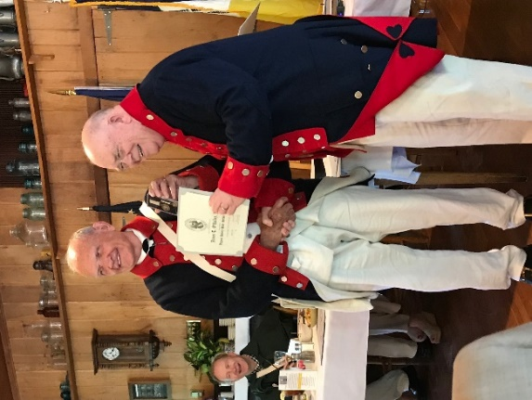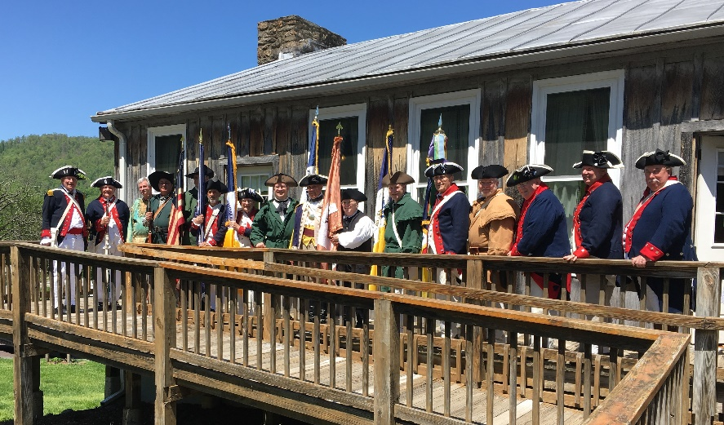
-7-
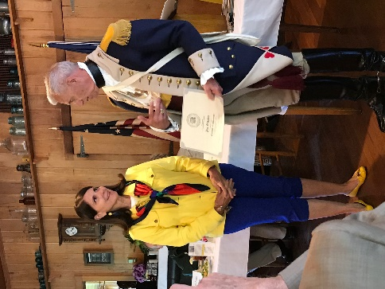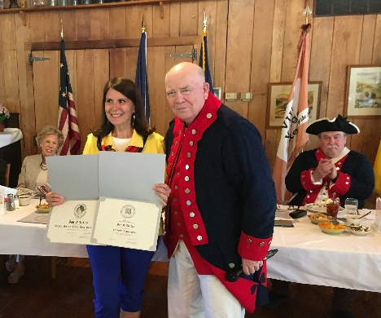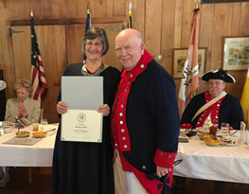
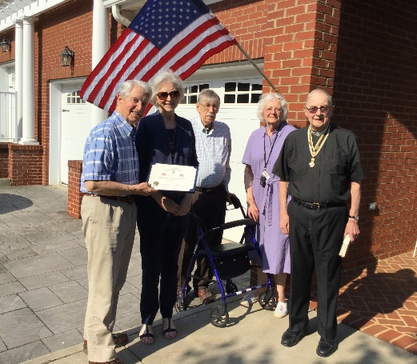

Flag Certificate Presentation – Seen here are Chaplain Minich doing the honors on MAY 19 , recognizing Joyce and Bill Siebert (on left), who fly the American flag year ‘round. Joining in (back center) are Compatriot T. C. Dickerson and his wife. All are residents of Westminster Canterbury of the Blue Ridge.

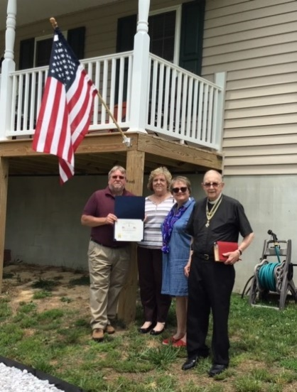

MAY 26th. Chaplain Minich has been busy this year with the Flag Certificate Program. He is seen here presenting this recognition to Danny and Jane Morris (at back). Standing next to Father Minich is Jane’s sister, Kathryn Mawyer. The Virginia Society, as a large state with many Chapters, has successfully managed to have all of its Chapters around the state, 28 now, present at least one Flag flying recognition for each of its Chapters for over 10 years in a row now. Thank you Father Minich.

On MAY 21st, President O’Kelley and Past VASSAR and Chapter President Kelly joined together to deliver the first History of American Flags Program at the Catholic School of Charlottesville. The program and the presentation proved to be most popular. After, they presented a Good Citizenship Award to an 8th Grader, Max Hathaway. (See next page)

-8-
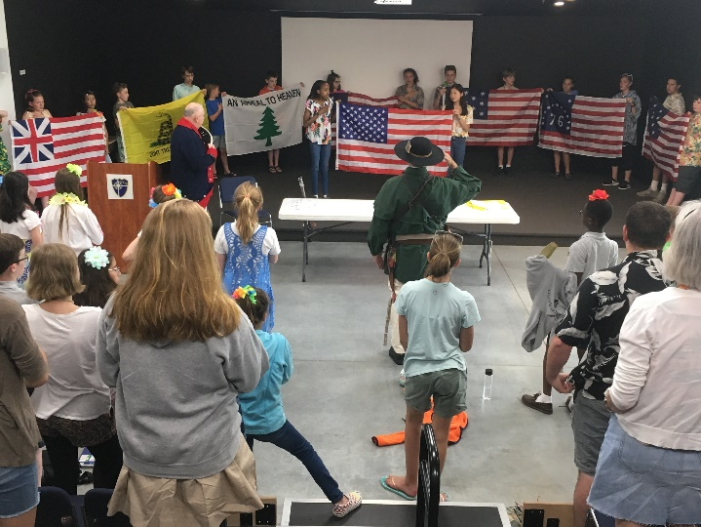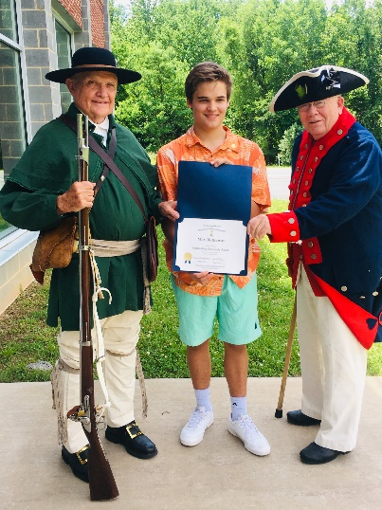

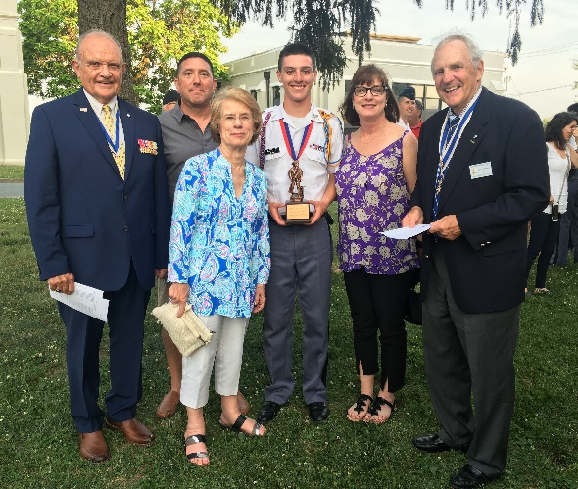
The Chapter thanks President O’Kelley and Past President Tilman for presenting the coveted Minute Man award to this young man, Jackson Edward Lloyd, at Fork Union Military Academy surrounded by his proud family. This is an award that was established, and underwritten, by Compatriot Harvey Hague many, many, years ago. The Chapter has presented Citizenship awards at fourteen schools and one JROTC award. Compatriots who have never had this experience, please help out, volunteer. It takes so little time and means so much to the awardees, their families and the schools.

MAY 27 Memorial Day, at Pavilion, Wreath Laying
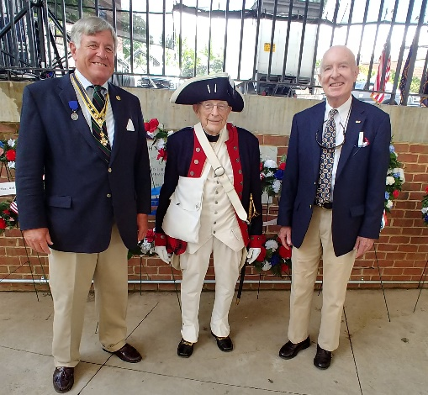
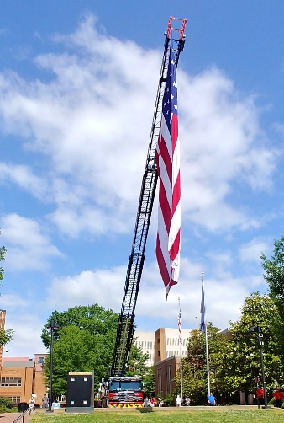
The Charlottesville Fire Department flies Old Glory with style and Compatriots Wallenborn, Cobham and Williams did the honors for both the Chapter and VASSAR. Meanwhile, in our Nation’s capital,
-9
President O’Kelley and two of his grandchildren, joined in the National Memorial Day Parade.
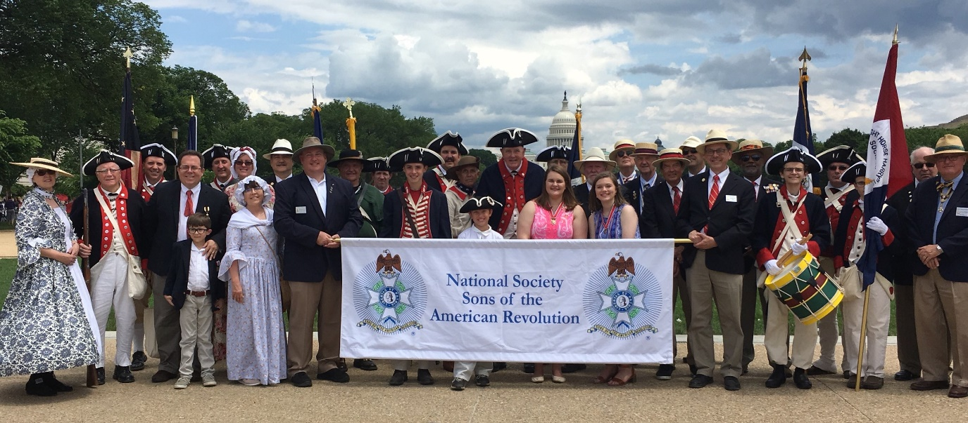
Here are President Jim’s grandchildren, Bailey and Blake, out front leading the SAR contingent.
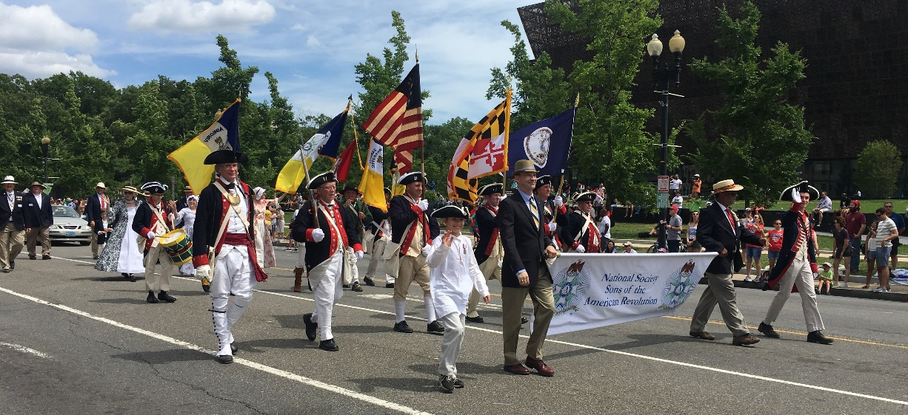
Here are Bailey and Blake with NSSAR President General Warren Alter and a proud grandfather holding the flag. The message… get your family and grandchildren involved in the SAR/DAR/ C.A.R.
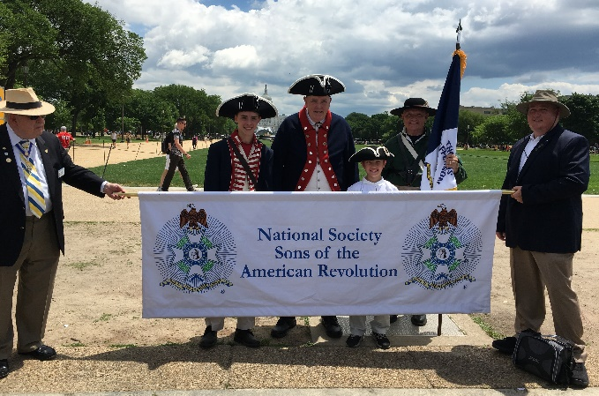
-10-
JUNE 1 Highlights at the Chapter Breakfast began with former VASSAR First Lady, Jennifer Kelly, sharing some of the challenges, accomplishments and some amusing stories about supporting her husband Pat during his prodigious term as State President. Then followed the induction of the Chapter’s newest member, Stephen Millard, who is also a member of the Jamestown Society.
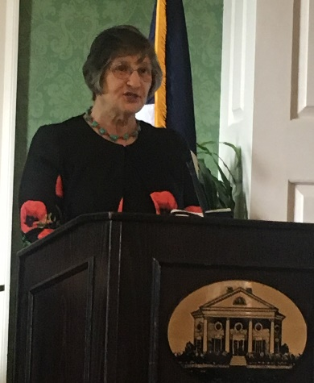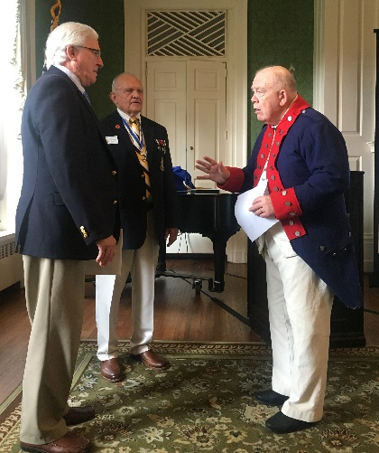
The biggest story of the morning was the VASSAR-authorized recognition of Past Chapter President, past VASSAR Surgeon, Color Guardsman Dr. Ken Wallenborn for his innumerable contributions to Charlottesville and the State over many years, both professional and civic, with a Silver Good Citizenship award. He then became the Key Note speaker and spoke so knowledgeably about America’s, and perhaps the world’s, most famous aviatrix, Amelia Earhart, and the tragic story about a ‘round the world flight from which, under some “mysterious” circumstances, she never returned. The Compatriots and ladies were spellbound hearing his interpretation of her demise and that of her navigator. President O’Kelley concluded the meeting by bringing to the attention of the membership some of the upcoming Opportunities for Participation.
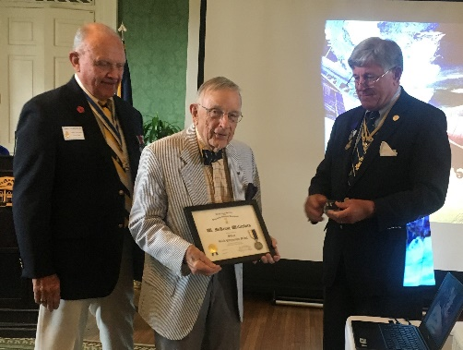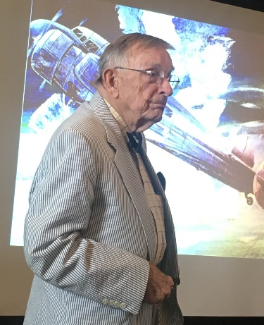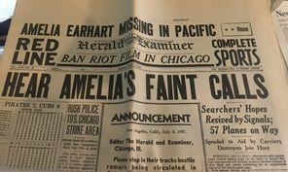
Monday July 5, 1937 Paper. Note the price, 3 cents.

-11- VASSAR NEWS
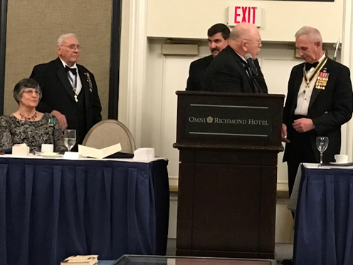
At the Evening Banquet, Pat Kelly, after a year at the State helm in which he did our Chapter and VASSAR proud as State President, passed the gavel to his successor, Judge Peter Davenport. Pat will be the VASSAR Trustee for a year. Also to be commended was our now former VASSAR First Lady, Jennifer, who accompanied Pat hither, thither and yon, one event after another. They travelled to Texas, Kentucky, Tennessee, Georgia, the Carolinas, Pennsylvania, the District of Columbia and all over the Commonwealth of Virginia.

NSSAR NEWS – National will meet in California in July 7-11 of 2019 in Costa Mesa, California.
An Essay of a JROTC Award Winner from New Jersey - Inspiring message from a young man who surely will be a leader in the coming years.
Daniel Herrera Cadet/Lieutenant - Lee-Davis HS NJROTC Unit
“How JROTC has prepared me to be a better citizen of the United States of America?”
As I twiddled my thumbs completely disinterested in my surroundings, I heard a voice that would change my life. “Attention on deck!”, called my Commanding Officer, indicating that INDOC, a one-week crash course that trains and guides new students to become NJROTC cadets, had just commenced. Her staff filed into the classroom in perfect sync--an incomparable fineness. I had no idea that those three simple words she uttered on that humid day in August, along with the impression her staff had on me, would be life changing. From learning the command “right face,” to developing my own personal philosophy, JROTC has prepared me to become an exceptional American.
The short time that we live on this planet comes down to one simple philosophy: to be a victim, or to persevere, prosper, and fearlessly lead by example. Many obstacles have arisen throughout my lifetime which have made me realize that it is my sole responsibility to learn to overcome them. I have had the privilege of being a member of numerous leadership organizations throughout my lifetime, but none has been able to deeply nurture me with the values of life more than NJROTC. I have had the privilege of being under the tutelage of my NJROTC instructors and past staff members who have molded me into becoming a future leader of this great country. They taught me the definition of failure; they taught me the bitter feeling of hitting rock bottom and the positivity of that occurrence which is that there is only one way to go from there--up. My NJROTC unit taught me the beauty of compromise and the art of listening to others. One of the John Daniel Herrera biggest lessons I have learned from NJROTC is being able to compromise. The beauty of compromise is that it allows for the fusion of the best of both worlds, and that it provides the best outcome for what is most important – the people one is working
-12-
for. However, my people weren’t always the American people. I was born on the small Spanish island of Ibiza in the Mediterranean Sea. I enjoyed a joyful childhood full of beautiful and rich memories that will forever be engraved in my heart. However, I am an American, not by birth or blood, but by naturalization. Being American is not defined by ethnicity, or nationality, or religion, or even a passport that you show abroad. Being American is a set of values and morals that shape one’s life. Being an American is an idea that one can come from humble circumstances and still have unlimited opportunities. NJROTC has deepened my love for America while giving me the tools to better serve it. The NJROTC program inspired me to fulfill my lifelong dream of becoming a pilot; I always dreamed of flying. NJROTC nurtured in me the idea of service, hence making me want to join the U.S. Navy. America gave me the opportunity to learn languages, to become a leader, and at my young age, to fulfill my vision of the American dream. I remember telling my friends in Spain that I would become a pilot, and they often laughed at me. They would reply with, ¨Stop dreaming. That’s not possible here.” Yet, the beauty of our land is that here anything is possible. In America, anything is truly possible. In life, we choose whether our glass is half empty or half full. I consider mine is half empty, not because I am a pessimist or a cynic, but rather because NJROTC taught me that I can make a difference. When we think that the glass is half full, we are often not motivated to fill it up any further. However, when we think the glass is half empty, we are inspired to find new ways to have a full glass. My glass of life and leadership is unbreakable because of the lessons that I have learned in NJROTC.
In only a few months, I will take the reins of my unit as Commanding Officer. I will remember my first day as a young cadet and all the lessons learned throughout the years. From a young seaman, to a Chief Petty Officer, to a Lieutenant, NJROTC has prepared me to become a better leader. While I wait to earn a seat in Congress or to make a difference in another area of government, I will continue to nurture and teach younger cadets left and right faces, to the rears and halts, because by learning how to do the small things right, the unimaginable can be achieved.
NECROLOGY – Tom Conner
OFFICERS – James O’Kelley, President; Geoff Cobham, Secretary and Event Coordinator; David Cooke, Vice President, Joel Strauch, Treasurer, Assist. Treasurer, Mackey Tilman, Rev. Cn. Henry Minich, Chaplain; Mark Chapman, Registrar; Pat Kelly, Historian; Harvey Hague, Chancellor; Dr. Ken. Wallenborn, Surgeon; Phil Williams, Publicist, and Joseph Garland, Photographer.
BOARD OF MANAGERS – Compatriots O‘Kelley, Tilman, Cobham, Kelly, Wallenborn; Williams; Minich; Hague; Chapman, Strauch. Emeritus: Lea Schultz
COLOR GUARD - P. Kelly (Chair), M. Day, K. Wallenborn, J. O’Kelley, P. Williams

-13-
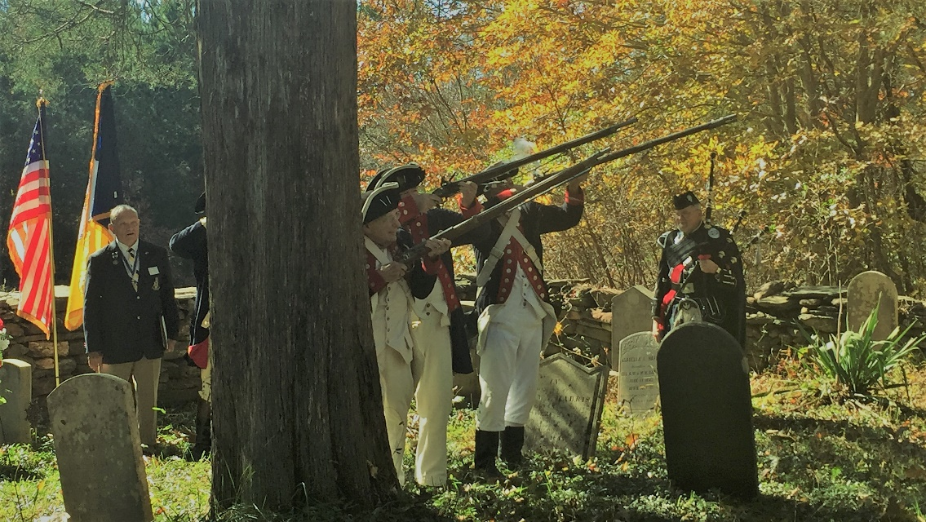
Your Chapter Musket-Firing Team (Compatriots Wallenborn, Day and Kelly), with President O’Kelley on the left on Chapter Registrar and Piper Mark Chapman at at right at a Rev war soldiers’ grave near Scottsville.

COMING EVENTS (MARK YOUR CALENDARS for the remainder of 2019)
July 4 Monticello Naturalization Ceremony, 9:00 - Joint Jack Jouett-TJ at Jefferson graveside, 10:45
President O’Kelley will serve woth VASSAR Color Guard at George Washington’s Tomb
Sept. 5 BOM at AMVEST, 4:00
Sept. 8 Chapter Garden Party, Ladies invited, 4:00, Venue TBD
Sept. 13,14 VASSAR Semi-Annual, Fairfax, Va.
Oct. 5 Chapter Breakfast, FCC, Pine Room, 8:45
Oct. 19 Yorktown Observance – a NSSAR-sanctioned observance
Nov. 7 BOM at ADVEST, 4:00
Nov. 11 Veterans’ Day ceremony at the Pavilion, 11:00
Dec. 7 Chapter Holiday Luncheon with Ladies, Greencroft, 11:30 Social, 12:00 Luncheon
Dec. 14 Wreaths Across America – a NSSAR-sanctioned event@ Dogwood Vietnam Memorial,
Charlottesville, Va.

